**CSE 3002:IWP**

**DA 2**

NAME: ABHEEK RAJEEV

REG NO:20BPS1039

INDEX.html:

<!DOCTYPE html>

<html>

<head>

  <title>COOKLOARDS - Home</title>

  <link rel="stylesheet" href="index.css">

</head>

<body>

  <header>

    <img src="images/logo2.png" alt="" width="auto" height="70">

    <nav>

      <ul>

        <li><a href="index.html" class="hover-underline-animation">Home</a></li>

        <li><a href="about.html" class="hover-underline-animation">About Us</a></li>

        <li><a href="menu.html" class="hover-underline-animation">Menu</a></li>

        <li><a href="reservation.html" class="hover-underline-animation">Reservation</a></li>

        <li><a href="delivery.html"class="hover-underline-animation">Cart</a></li>

      </ul>

    </nav>

  </header>

  <!-- <nav>

    <div class="navbar-logo">

      <a href="index.html"><img src="images/logo2.png" alt="Logo" class="Logo"></a>

    </div>

    <div class="navbar-links">

      <a href="index.html">Home</a>

      <a href="about.html">About Us</a>

      <a href="menu.html">Menu</a>

      <a href="reservation.html">Reservation</a>

      <a href="delivery.html">Cart</a>

    </div>

  </nav> -->

  <main>

    <div class="body-res">

      <img src="images/logo.png" alt="">

    </div>

    <div class="body-welcome">

      <h1>Welcome to COOKLOARDS</h1><br><br>

      <p>Enjoy the best dining experience with us</p><br>

      <p>Cookloards creatively modernizes the age-old flavors of India.</p><br>

      <p>Our cuisine is proudly inspired by India, with a distinctly New York touch — served nightly in a space that is

        as elegant as it is lively.</p><br>

      <p>We look forward to welcoming you in</p><br><br>

      <button class="button1"><a href="menu.html">View Menu</a></button>

    </div>

    <form onsubmit="storelocator(); return false;">

      <fieldset>

        <legend>Choose the Store</legend><br>

        <label for="location">Location:</label>

        <select name="location" id="location">

          <option value="chennai">Chennai</option>

          <option value="mumbai">Mumbai</option>

        </select>

        <button type="button" onclick="storelocator(); return false;">submit</button>

      </fieldset>

    </form>

    <div class="ph-head"> <h1>GALLERY</h1><br><br></div>

    <div class="interior">

      <div class="first"><img id="first-img" src="images/interior.webp" alt="interior image" width="50%"><br></div>

      <div class="second"><img id="second-img" src="images/interior2.webp" alt="interior image"width=50%></div>

    </div>

    <div><p style="background-color: #333;

      color: white;

      text-align: centre;

      display: flex;

      justify-content: center;

      padding: 20px 0;

      margin-top: 50px;">

      &copy; 2023 COOKLOARDS</p>

    </div>

    <script src="interior.js"></script>

  </main>

</body>

</html>

INDEX.CSS:

/* body {

    font-family: Arial, sans-serif;

    background-color: #f2f2f2;

  }

  header h1, section h2 {

    font-size: 2em;

    margin-top: 0;

    padding: 1em;

  }

  p {

    font-size: 1.2em;

    margin: 0;

    padding: 1em;

  }

  main {

    max-width: 800px;

    margin: 0 auto;

  }

  section {

    background-color: #fff;

    padding: 1em;

  }

  img {

    width: 100%;

    margin-bottom: 1em;

  }

  nav {

    background-color: #333;

    display: flex;

    justify-content: space-between;

    align-items: center;

    height: 50px;

  }

  nav a {

    color: white;

    text-decoration: none;

    padding: 0 10px;

    font-size: 16px;

  }

  nav a:hover {

    background-color: #555;

  }

  nav a.active {

    background-color: #4CAF50;

  }

  Set font size and background color for buttons

  button {

    font-size: 1.2em;

    background-color: #008CBA;

    color: #fff;

    padding: 1em;

    border: none;

    border-radius: 5px;

    margin: 1em;

  }

  footer {

    font-size: 1.2em;

    margin-top: 2em;

    text-align: center;

    background-color: #ccc;

    padding: 1em;

  } */

  @import url('https://fonts.googleapis.com/css2?family=Tangerine&display=swap');

*{

    margin: 0;

    padding: 0;

}

body {

  font-family: Arial, sans-serif;

  margin: 0;

  padding: 0;

  background-color: #F2F3EE;

}

ul {

  list-style: none;

  margin: 0;

  padding: 0;

}

a {

  text-decoration: none;

  color: #333;

}

/* Header */

header {

  background-color: #fff;

  box-shadow: 0px 2px 4px rgba(0, 0, 0, 0.2);

  display: flex;

  justify-content: space-between;

  align-items: center;

  padding: 10px 30px;

}

header h1 {

  margin: 0;

  font-size: 24px;

}

nav ul {

  display: flex;

}

nav li {

  margin-left: 20px;

}

nav a {

  font-size: 16px;

}

.hover-underline-animation {

  display: inline-block;

  position: relative;

  color:  #333;

}

.hover-underline-animation:after {

  content: '';

  position: absolute;

  width: 100%;

  transform: scaleX(0);

  height: 2px;

  bottom: 0;

  left: 0;

  background-color:  #333;

  transform-origin: bottom right;

  transition: transform 0.25s ease-out;

}

.hover-underline-animation:hover:after {

  transform: scaleX(1);

  transform-origin: bottom left;

}

/* body {

    font-family: Arial, sans-serif;

    background-color: #f2f2f2;

}

nav {

    background-color:white;

    padding-bottom: 30px;

    display: flex;

    justify-content: space-between;

    align-items: center;

    height: 50px;

    color: white;

    justify-content: space-between;

}

.navbar-links a{

    color: black;

    padding-left: 20px;

    padding-right: 20px;

}

.Logo{

    padding-top: 30px;

    height: 70px;

    width: auto;

} */

form {

  margin: 20px;

  padding: 20px;

  border: 1px solid #ccc;

  background-color: #f5f5f5;

}

fieldset {

  border: none;

  margin: 0;

  padding: 0;

}

legend {

  font-weight: bold;

}

label {

  display: block;

  margin-bottom: 10px;

}

select {

  padding: 5px;

  margin-bottom: 10px;

}

button {

  padding: 10px;

  background-color: #0077cc;

  color: #fff;

  border: none;

  cursor: pointer;

}

button:hover {

  background-color: #005fa3;

}

.body-res{

  background-image: url("images/restaurent.png");

  background-size: 1200px auto;

  background-repeat: no-repeat;

  background-position: center;

  height: 95vh;

  width: 100%;

  text-align: center;

}

.body-res img{

  height: 400px;

  padding-top: 90px;

}

.body-welcome{

  font-family: 'Tangerine', cursive;

  height: 500px;

  align-items: center;

  text-align: center;

  background-color: #f2f2f2;

  border: 1px solid green;

  margin: 50px 90px;

}

.body-welcome h1{

  padding-top: 100px;

  font-size: 60px;

}

.body-welcome p{

  font-size: 30px;

}

.body-welcome .button1{

  border:black solid 3px;

  color: black;

  border-radius: 10%;

  width: 100px;

  height: 40px;

  background-color: #ccc;

}

.body-welcome button:hover{

 background-color: rgb(220, 171, 79);

 color: white;

}

.body-welcome a{

  color: black;

  text-decoration: none;

}

.interior{

  /* align-items: center;

  text-align: center; */

  display:flex;

  justify-content: space-between;

  gap: 5px;

}

.first{

  flex: 1;

  width: 50%;

}

.second{

  flex: 2;

  width: 50%;

}

.interior img{

  height: 500px;

  width: auto;

}

.ph-head{

  text-align: center;

  padding-top: 50px;

  padding-bottom: 0;

  margin-bottom: 0;

}

footer{

  background-color: black;

  height: 50px;

  color: white;

  text-align: center;

}

footer p{

  padding-top: 20px;

}

JAVASCRIPT FOR INDEX.html(INTERIOR.js)

function storelocator()

{

    var loc=document.getElementById("location");

    var val = loc.value;

    console.log(val);

    if(val=="chennai")

    {

        document.getElementById("first-img").src="images/interior.webp";

        document.getElementById("second-img").src="images/interior2.webp";

    }

    if(val=="mumbai")

    {

        document.getElementById("first-img").src="images/res2-int1.jpg";

        document.getElementById("second-img").src="images/res2-int2.jpg";

    }

}

About.html:

<!DOCTYPE html>

<html>

<head>

    <title>Restaurant Name - About Us</title>

</head>

<link rel="stylesheet" href="about.css">

<body>

    <header>

        <img src="images/logo2.png" alt="" width="auto" height="70">

        <nav>

            <ul>

                <li><a href="index.html" class="hover-underline-animation">Home</a></li>

                <li><a href="about.html" class="hover-underline-animation">About Us</a></li>

                <li><a href="menu.html" class="hover-underline-animation">Menu</a></li>

                <li><a href="reservation.html" class="hover-underline-animation">Reservation</a></li>

                <li><a href="delivery.html" class="hover-underline-animation">Cart</a></li>

            </ul>

        </nav>

    </header>

    <main>

        <section>

            <h2>About Cookloards</h2>

            <p>Cookloards is a family-owned restaurant that has been serving delicious traditional food for over 50

                years. Our recipes have been passed down through generations and we take pride in using fresh,

                high-quality ingredients in every dish we serve.</p>

        </section>

        <section>

            <h2>Our Philosophy</h2>

            <ul>

                <li>We believe that food is not just about nourishment, but also about bringing people together.</li>

                <li>We are committed to using fresh, high-quality ingredients in every dish we serve.</li>

                <li>We strive to create a warm and welcoming atmosphere for all of our guests.</li>

                <li>We believe in giving back to our community by supporting local charities and organizations.</li>

            </ul>

        </section>

        <section>

            <h2>Our Menu</h2>

            <p>We offer a wide range of dishes to satisfy every taste bud. From hearty stews and soups to savory meat

                dishes and fresh salads, we have something for everyone. Our menu also includes a variety of vegetarian

                and gluten-free options.</p>

        </section>

        <section class="team">

            <h2>Our Team</h2>

            <ul>

                <li>

                    <img src="images/chef1.jpg" alt="Chef 1" width="500" height="auto"><br><br>

                    <h3>Pierre La Boulangerie</h3><br>

                    <p>Pierre La Boulangerie was born and raised in Paris, France. As a child, he spent countless hours

                        in his grandmother's kitchen, learning the art of French baking. After studying culinary arts in

                        Paris, Pierre moved to New York City to pursue his dreams of becoming a renowned pastry chef.

                    </p>

                    <p>He quickly rose to fame with his unique approach to traditional French baking, incorporating

                        unexpected ingredients such as matcha and yuzu into classic pastries. His signature dish, the

                        "Matcha Croissant," became an instant hit among New York's foodies.</p>

                    <p>Pierre's passion for baking extends beyond the kitchen. He is a vocal advocate for sustainable

                        agriculture and often sources his ingredients from local farms. In his free time, he volunteers

                        at a local food bank, sharing his love of baking with the community.</p>

                    <p><b>Pierre has been recognized with numerous awards and accolades</b>, including being named "Best Pastry

                        Chef in New York" by the James Beard Foundation. He has also authored several cookbooks,

                        including "Baking with Matcha" and "The Yuzu Revolution."</p>

                </li><br><br>

                <li>

                    <img src="images/chef2.jpg" alt="Chef 2" width="500" height="auto"><br><br>

                    <h3>Heston Blumenthal</h3><br>

                    <p>Heston Blumenthal is a renowned British chef known for his innovative and scientific approach to

                        cooking. Blumenthal's cooking style is characterized by his use of modern techniques and his

                        interest in the science behind food. He is famous for experimenting with unusual flavor

                        combinations, unusual cooking methods, and unexpected ingredients.2</p>

                    <p>Blumenthal is particularly known for his work in molecular gastronomy, a type of cooking that

                        involves the use of scientific techniques and equipment to create new textures, flavors, and

                        presentations. He has developed a number of new cooking techniques, such as the use of liquid

                        nitrogen to create ice creams and other frozen dishes.</p>

                    <p>Throughout his career, Blumenthal has been recognized with numerous awards and honors, including

                        multiple Michelin stars and an OBE for his contributions to British gastronomy. He has also

                        published several cookbooks, including "The Fat Duck Cookbook" and "Heston Blumenthal at Home,"

                        which offer readers an inside look at his unique approach to cooking.</p>

                </li>

            </ul>

        </section>

        <section class="test">

            <h2>Testimonials</h2>

            <div class="testimonial-container">

                <div class="testimonial">

                    <p>"Cookloards is the best restaurant in town! The food is always fresh, hot, and delicious. I

                        highly recommend their seafood dishes - they're out of this world!"</p>

                    <p class="author"><i>- John Doe</i></p>

                </div>

                <div class="testimonial">

                    <p>"I had an amazing experience at Cookloards. The staff were so friendly and accommodating, and the

                        ambiance of the restaurant was perfect for a night out. The steak I had was cooked to perfection

                        and melted in my mouth."</p>

                    <p class="author"> <i> - Jane Smith</i></p>

                </div>

                <div class="testimonial">

                    <p>"I recently visited Cookloards for a family dinner and was blown away by the quality of the food.

                        The menu had a great variety of options, and everything we ordered tasted fantastic. We can't

                        wait to go back!"</p>

                    <p class="author"> <i>-Michael Johnson</i> </p>

                </div>

                <div class="testimonial">

                    <p>"I am a regular customer at Cookloards and have never been disappointed. The food is consistently

                        delicious, and the service is always top-notch. I highly recommend their pasta dishes - they're

                        some of the best I've ever had!"</p>

                    <p class="author"> <i>- Sarah Lee</i> </p>

                </div>

                <div class="testimonial">

                    <p>"Cookloards is hands down the best restaurant in town. The portions are generous, the flavors are

                        incredible, and the prices are reasonable. I have recommended this restaurant to all of my

                        friends and family, and they have all loved it as much as I do."</p>

                    <p class="author"> <i>- Tom Brown</i> </p>

                </div>

            </div>

        </section>

    </main>

    <footer>

        <p>&copy; 2023 COOKLOARDS</p>

    </footer>

</body>

</html>

About.css:  
  
@import url('https://fonts.googleapis.com/css2?family=Tangerine&display=swap');

body {

    font-family: Arial, sans-serif;

    margin: 0;

    padding: 0;

    text-align: center;

    background-color: #F5F5F5;

}

ul {

    list-style: none;

    margin: 0;

    padding: 0;

}

a {

    text-decoration: none;

    color: #333;

}

.hover-underline-animation {

    display: inline-block;

    position: relative;

    color:  #333;

}

.hover-underline-animation:after {

    content: '';

    position: absolute;

    width: 100%;

    transform: scaleX(0);

    height: 2px;

    bottom: 0;

    left: 0;

    background-color:  #333;

    transform-origin: bottom right;

    transition: transform 0.25s ease-out;

}

.hover-underline-animation:hover:after {

    transform: scaleX(1);

    transform-origin: bottom left;

}

/* Header */

header {

    background-color: #fff;

    box-shadow: 0px 2px 4px rgba(0, 0, 0, 0.2);

    display: flex;

    justify-content: space-between;

    align-items: center;

    padding: 10px 30px;

}

header h1 {

    margin: 0;

    font-size: 24px;

}

nav ul {

    display: flex;

}

nav li {

    margin-left: 20px;

}

nav a {

    font-size: 16px;

}

.testimonial-container {

    display: flex;

    flex-wrap: wrap;

    justify-content: center;

    align-items: center;

    margin-top: 50px;

  }

  .testimonial {

    width: 400px;

    height: 200px;

    margin: 20px;

    padding: 20px;

    border: 1px solid #ccc;

    border-radius: 10px;

    background-color: #f9f9f9;

    text-align: center;

  }

  .testimonial p {

    font-size: 18px;

    line-height: 1.5;

  }

  .testimonial .author {

    margin-top: 20px;

    font-style: italic;

    font-size: 16px;

  }

  h2{

    font-family: 'Tangerine', cursive;

    font-size: 70px;

  }

  section{

    padding: 50px 150px;

  }

  .text{

    padding: 50px 0;

  }

  .team p{

    padding: 10px 180px;

  }

  /* p{

    font-size: 20px;

    padding-left: 100px;

    padding-right: 100px;

  } */

  footer {

    background-color: #333;

    color: #fff;

    padding: 20px 30px;

    text-align: center;

}

footer p {

    margin: 0;

    font-size: 14px;

}

MENU.html:

<!DOCTYPE html>

<html>

<head>

    <title>Restaurant Menu</title>

    <link rel="stylesheet" href="menu.css">

</head>

<header>

    <img src="images/logo2.png" alt="" width="auto" height="70">

    <nav>

        <ul>

            <li><a href="index.html" class="hover-underline-animation">Home</a></li>

            <li><a href="about.html" class="hover-underline-animation">About Us</a></li>

            <li><a href="menu.html" class="hover-underline-animation">Menu</a></li>

            <li><a href="reservation.html" class="hover-underline-animation">Reservation</a></li>

            <li><a href="delivery.html"class="hover-underline-animation">Cart</a></li>

        </ul>

    </nav>

</header>

<body>

    <main>

    <h1 style="display: flex;justify-content: center;padding-bottom: 10px;font-family: 'Tangerine', cursive; font-size: 100px;">Restaurant Menu</h1>

    <nav class="nav2">

        <a href="#" id="golden" onclick="keepone(); return false;" class="hover-underline-animation">GOLDEN HOUR</a>

        <a href="#" id="DINNER" onclick="keeptwo(); return false;" class="hover-underline-animation">DINNER</a>

        <a href="#" id="dessert" onclick="keepthree(); return false;" class="hover-underline-animation" >DESSERT</a>

        <a href="#" id="cocktails" onclick="keepfour(); return false;" class="hover-underline-animation">COCKTAILS</a>

        <a href="#" id="brunch" onclick="keepfive(); return false;" class="hover-underline-animation">BRUNCH</a>

    </nav>

    <div class="menu-details">

        <section id="golden-hour-text" >

            <div class="menu-description container-sm">

                <h3>Available Monday-Friday | 5-6PM | $39</h3>

                <p>&nbsp;</p>

                <h2>FIRST COURSE</h2>

                <p><em>Choice of One</em></p>

                <p>BENGALI BEET CHOP<br>Winter Vegetables, Potatoes, Kasundi Mayo (V)*</p>

                <p>SHRIMP KOLIWADA<br>Popcorn Style Fritters, Pickled Mango Sauce (GF)</p>

                <p>SONA PIZZA<br>Choice of Tandoori Chicken or Paneer</p>

                <p><br></p>

                <h2>MAIN COURSE</h2>

                <p><em>Choice of One</em></p>

                <p>ANDHRA VEGETABLE CURRY<br>Seasonal Vegetables, Gongura Leaves, Coconut (V, GF)</p>

                <p>VINDALOO BBQ PORK RIBS<br>Sticky Chili Glaze, Mango, Pickled Onion (GF)</p>

                <p>BURRATA BUTTER CHICKEN<br>Tandoor Roasted Chicken, Creamy Tomato Sauce (GF)</p>

                <p>GOAN FISH CURRY<br>Coconut Clam Broth, Kokum, Red Rice (GF)</p>

                <p><br></p>

                <h2>TAKEAWAY DESSERT</h2>

                <p>Chocolate Dipped Pistachio Shortbread Cookies</p>

                <p><br></p>

                <h2>COCKTAILS +17</h2>

                <p>MIMI'S MARGARITA<br>Milagro Silver Tequila, Chile Liqueur, Lime, Birdâ€™s Eye Chili, Cilantro, Agave

                </p>

                <p>SPA DAY<br>Smoke Lab Vodka, Aloe, Cucumber, Lime, Simple, Club Soda</p>

                <p>GOLD NEGRONI<br>Jaisalmer Gin, Pamplemousse Liqueur, Saffron Liqueur, Sweet Vermouth, Dry Vermouth

                </p>

                <p>75 SUITORS<br>Jin-Jiji India Dry Gin, Aperol, Strawberry, Rosemary, Lemon, Eau de Rose, Simple,

                    Prosecco</p>

                <p><br></p>

                <h2>SPIRIT SHY +6</h2>

                <p>PEACH PLEASE<br>Peach Puree, Honey, Lime, Ginger Beer</p>

                <p>MANGO LASSI<br>Mango Puree, Yogurt</p>

                <p><br></p>

                <h2>WINE BY THE GLASS +15</h2>

                <p>Bodegas Muga, Rioja Rosado, SP (2021) Garnacha, Tempranillo</p>

                <p>Framingham, Marlborough, NZ (2021) Sauvignon Blanc</p>

                <p>Altos Ibericos, Rioja, Crianza, SP (2017) Tempranillo</p>

                <p><br></p>

                <h2>BEER +7</h2>

                <p>STELLA ARTOIS | ABV 5.2%</p>

                <p>FOUNDERS CENTENNIAL IPA | ABV 7.2%</p>

                <p><br></p>

                <p>*Vegan or can be prepared vegan. Consuming raw or undercooked meats, poultry, seafood, shellfish or

                    eggs may increase your risk of foodborne illness.</p>

            </div>

        </section>

        <section id="dinner-text">

            <div class="menu-description container-sm">

                <h2>TO START</h2>

                <p>AVOCADO PAPDI CHAAT <strong>22</strong><br>Masala Guacamole, Crispy Taro Chips (VG, GF)</p>

                <p>ROASTED PAPAD &amp; CHUTNEYS (V, GF) <strong>8</strong><br>Variety of Lentil and Rice Crackers with

                    Dips</p>

                <p><br></p>

                <h2>SMALL PLATES</h2>

                <p>BENGALI BEET CHOP <strong>18</strong><br>Roasted Red Beet Croquettes, Kasundi Mayo (V)*</p>

                <p>THECHA PANEER TIKKA <strong>22</strong><br>Riverrine Ranch Buffalo Milk Cheese, Spicy Peanut Green

                    Chili Chutney (V, GF)</p>

                <p>SHRIMP KOLIWADA <strong>28</strong><br>Popcorn Style Fritters, Pickled Mango Sauce (GF)</p>

                <p>BRISKET SHAMI KEBAB <strong>22</strong><br>Ground Beef, Chana Dal, Garam Masala&nbsp;</p>

                <p>HEIRLOOM CARROT SALAD <strong>16</strong><br>Chaat Masala, Pumpkin Seeds, Mixed Greens (V)*</p>

                <p>AAM PANNA CRUDO <strong>22</strong><br>Cured Hamachi Crudo, Green Mango, Cucumber, Fermented Chili

                    (GF)</p>

                <p>ROASTED OYSTERS <strong>21</strong><br>Green Butter Roasted Oysters (1/2 Dozen)</p>

                <p><br></p>

                <h2>THE SONA PIZZA 24</h2>

                <p>CHICKEN TIKKA<br>Burrata, Roasted Tomato Sauce</p>

                <p>CHILI PANEER<br>Spiced Paneer, Jalapeno (V)</p>

                <p>TRUFFLE MALAI MUSHROOM<br>Ricotta, Wild Mushroom Medley (V)</p>

                <p><br></p>

                <h2>FROM THE GRILL</h2>

                <p>AMRITSARI MURG <strong>44</strong><br>Roasted Sundance Farm Chicken, Roasted Garlic Yogurt (GF)</p>

                <p>VINDALOO BBQ PORK RIBS <strong>42</strong><br>Sticky Chili Glaze, Mango, Pickled Onion (GF)</p>

                <p>TAMARIND LAMB CHOPS <strong>54</strong><br>Smoked Chili, Fennel Slaw, Garlic Raita (GF)</p>

                <p>GRILLED BRANZINO <strong>48</strong><br>Green Chili, Kasundi Malai Curry (GF)</p>

                <p>MALABAR PEPPERCORN STEAK <strong>48</strong><br>Tender Bavette Steak, Wild Mushrooms, Spiced Jus (GF)

                </p>

                <p><br></p>

                <h2>ENTRÃ‰E</h2>

                <p>ANDHRA VEGETABLE CURRY <strong>28</strong><br>Seasonal Vegetables, Gongura Leaves, Coconut (V, GF)

                </p>

                <p>SARSON KA SAAG <strong>28</strong><br>Punjabi Mustard Greens, Corn Roti (V)*</p>

                <p>TRAVANCORE TOMATO DAL <strong>26</strong><br>Fermented Lentil Fritters, Curry Leaf Tadka (VG)</p>

                <p>FLOYDâ€™S GOAN FISH CURRY <strong>36</strong><br>Coconut Clam Broth, Kokum, Red Rice (GF)</p>

                <p>BURRATA BUTTER CHICKEN <strong>32</strong><br>Tandoor Roasted Chicken, Creamy San Marzano Tomato

                    Butter Masala (GF)</p>

                <p>RAILWAY MUTTON MASALA <strong>42</strong><br>Slow Cooked Lamb Shoulder, Fingerling Potatoes (GF)</p>

                <p><br></p>

                <h2>VEGETABLES</h2>

                <p>GRILLED EGGPLANT <strong>30</strong><br>Smoked Eggplant Chokha, Hierloom Tomato Salad (VG, GF)</p>

                <p>ROASTED CAULIFLOWER <strong>26</strong><br>Turmeric, Green Chili, Indian Cheddar Cheese (V, GF)</p>

                <p>RAJASTANI OKRA <strong>28</strong><br>Crisp Masala Okra, Yogurt Sauce (V, GF)</p>

                <p>WILD MUSHROOM PEPPER ROAST <strong>28</strong><br>Spicy Chettinad Masala (VG, GF)</p>

                <p><br></p>

                <h2>BIRIYANI</h2>

                <p>KOLKATA LAMB BIRIYANI<strong>&nbsp;42</strong><br>Saffron Yakhni Rice, Steamed Potatoes, Raita (GF)

                </p>

                <p>HYDERABADI CHICKEN BIRIYANI<strong>&nbsp;34</strong><br>Saffron Rice, Mint, Crispy Onions (GF)</p>

                <p>AWADHI VEGETABLE BIRYANI<strong>&nbsp;32</strong><br>Saffron Rice, Seasonal Vegetable, Raita (V, GF)

                </p>

                <p><br></p>

                <h2>BREADS</h2>

                <p>NAAN (V)<br>Butter <strong>8</strong> | Garlic <strong>8</strong> | Chili Cheese <strong>10</strong>

                </p>

                <p>MULTIGRAIN ROTI (VG)<strong>&nbsp;8</strong></p>

                <p>BUTTER CHICKEN KULCHA<strong>&nbsp;10</strong></p>

                <p><br></p>

                <h2>ACCOMPANIMENTS</h2>

                <p>RICE (VG, GF) <strong>8</strong><br>Steamed Basmati | Goan Red Rice</p>

                <p>RAITA (GF) <strong>6</strong><br>Roasted Eggplant | Cucumber</p>

                <p>PICKLE PLATE (VG, GF) <strong>6</strong><br>House Made Pickled Radish, Carrots &amp; Green Mango</p>

                <p><br></p>

                <p>*Vegan or can be prepared vegan<br>Consuming raw or undercooked meats, poultry, seafood, shellfish or

                    eggs may increase your risk of food-borne illness.</p>

            </div>

        </section>

        <section id="dessert-text">

            <div class="menu-description container-sm">

                <h2>CAKES &amp; SUCH 14</h2>

                <p>KULFI FALOODA<br>Saffron Noodles, Basil Seeds, Rose Hips</p>

                <p>GAJAR HALWA<br>Carrot Cake, Pistachio Crumb, Ginger Frozen Yogurt</p>

                <p>SAFFRON JALEBI<br>Aerated Rabdi, Milk Cake, Lychee</p>

                <p><br></p>

                <h2>ICE CREAMS &amp; SORBETS 10</h2>

                <p>MASALA CHAI ICE CREAM<br>Caramelized White Chocolate Crumble</p>

                <p>PINK GUAVA SORBET<br>Chili Salt, Guava Candy</p>

                <p>TENDER COCONUT ICE CREAM<br>Rum Poached Pineapple</p>

                <p><br></p>

                <h2>TO FINISH</h2>

                <p>WAKE ME UP IN DELHI <strong>19</strong><br>Espresso, Vanilla Infused Vodka, Mr Black Cold Brew Coffee

                    Liqueur, Lucano Amaro, Chai Spiced Cream</p>

                <p><br></p>

                <h2>PORTS</h2>

                <p>ROYAL TOKAJI, LATE HARVEST TOKAJ <strong>16</strong></p>

                <p>DONA ANTONIA, RESERVA TAWNY <strong>15</strong></p>

                <p>GRAHAM'S 40 TAWNY PORT <strong>45</strong></p>

                <p><br></p>

                <h2>APERITIFS</h2>

                <p>AMARO MONTENEGRO PREMIATA 1885 SPECIALITA, BOLOGNA, ITALY <strong>17</strong></p>

                <p>LUSTAU DON NUÃ‘O SECOâ€€DRY JEREZâ€€XÃˆRÃˆSâ€€SHERRY, SPAIN <strong>15</strong></p>

                <p>CYNAR, AMARO APERITIF AND VERMOUTH, ITALY <strong>17</strong></p>

                <p>FRANGELICO, HAZELNUT AND HERBAL LIQUEUR, ITALY <strong>15</strong></p>

                <p>DISARONNO AMARETTO, ITALY <strong>16</strong></p>

                <p>AVERNA AMARO SICILIANO 1868, ITALY <strong>18</strong></p>

                <p>BAILEYS IRISH CREAM, IRELAND <strong>15</strong></p>

                <p>SAMBUCA ROMANA, ITALY <strong>15</strong></p>

            </div>

        </section>

        <section id="cocktails-text">

            <div class="menu-description container-sm">

                <h2>SPIRIT FORWARD</h2>

                <p>THE OTHER WOMAN <strong>25</strong><br>Banhez Mezcal, Laphroaig 10yr Islay Scotch, Blackened Birdâ€™s

                    Eye Chili Tincture, Grapefruit Bitters, Agave</p>

                <p>STARDUST <strong>22</strong><br>Kansas Whiskey, Elderflower Liqueur, Amaro Montenegro</p>

                <p>DEEP IN LOVE <strong>20</strong><br>Casamigos Reposado, Cachaca, Rose Liqueur, Hisbiscus Syrup, Black

                    Salt</p>

                <p>GOLD NEGRONI <strong>19</strong><br>Jaisalmer Gin, Pamplemousse Liqueur, Saffron Liqueur, Sweet

                    Vermouth, Dry Vermouth</p>

                <p>75 SUITORS <strong>19</strong><br>Jin-Jiji India Dry Gin, Aperol, Strawberry, Rosemary, Lemon, Eau de

                    Rose, Simple, Prosecco</p>

                <p>MIMI'S MARGARITA <strong>20</strong><br>Milagro Silver Tequila, Chile Liqueur, Lime, Birdâ€™s Eye

                    Chili, Cilantro, Agave</p>

                <p>THE GIRL FROM GOA <strong>22</strong><br>Genepy Herbetet, Lychee Liqueur, Darjeeling Tea, Lemon,

                    Ginger, Black Peppercorn, Honey, Paprika</p>

                <p>KUCHIPUDI <strong>24</strong><br>Mezcal, Elderflower Liqueur, Wasabi, Ginger, Birdâ€™s Eye Chili,

                    Mint, Buzz Button, Lime, Agave</p>

                <p>SPA DAY <strong>19</strong><br>Smoke Lab Vodka, Aloe, Cucumber, Lime, Simple, Club Soda</p>

                <p>SMOKED FASHION <strong>20</strong><br>Old Grand Dad Bourbon Whiskey, Demerara, Angostura, and Orange

                    Bitters</p>

                <p><br></p>

                <h2>SPIRIT SHY 14</h2>

                <p>PEACH PLEASE<br>Peach Puree, Honey, Lime, Ginger Beer</p>

                <p>LYCHEE PARADISE<br>Lychee, Darjeeling Black Tea, Lemon, Honey</p>

                <p>MANGO MALAI<br>Mango Puree, Yogurt</p>

                <p>KOKUM MOJITO<br>Kokum, Mint, Lime, Simple, Soda</p>

                <p><br></p>

                <h2>GIN &amp; TONICS 22</h2>

                <p>NO. 1*<br>Bombay Sapphire Gin, Lemon, Vanilla, Orange Bitters, Eau de Orange Blossom, Star Anise</p>

                <p>NO. 2*<br>Empress Gin, Lychee Liqueur, Lychee, Lemon, Honey</p>

                <p>NO. 3*<br>Jin-JiJi India Dry Gin, Elderflower Liqueur, Grapefruit, Mint</p>

                <p>NO. 4*<br>Hendricks Gin, Berries, Rose Liqueur, Cynar, Lemon</p>

                <p>*Keep the Straw? <strong>+7</strong></p>

                <p><br></p>

                <h2>BEER</h2>

                <p>KINGFISHER PALE LAGER, ABV 4.8% | <strong>8</strong></p>

                <p>FOUNDERS CENTENNIAL IPA, ABV 7.2% | <strong>9</strong></p>

                <p>SAISON DUPONT BELGIUM ALE, ABV 6.5% | <strong><strong>10</strong></strong></p>

                <p>STELLA ARTOIS, ABV 5.2% | <strong>8</strong></p>

                <p>HEINEKEN ZERO, ABV 0.0% | <strong><strong>7</strong></strong></p>

                <h2><br></h2>

                <h2>WINE BY THE GLASS</h2>

                <p>SPARKLING<br>Jeio, Prosecco, Veneto, IT (NV) <strong>19/75</strong><br>Fiol RosÃ©, Prosecco, Veneto,

                    IT (2020) <strong>20/80</strong><br>Louis de Sacy, Brut Originel, Champagne, FR (NV)

                    <strong>27/108</strong><br>La Battagliola, Lambrusco, Grasparossa, (2021) <strong>19/75</strong></p>

                <p>ROSE<br>Peyrassol La Croix, Provance, FR (2021) RosÃ© <strong>20/80</strong><br>Bodegas Muga, Rioja

                    Rosado, SP (2021) Garnacha, Tempranillo <strong>20/80</strong></p>

                <p>WHITE<br>Pago del Cielo, Rueda, SP (2020) Verdejo <strong>18/72</strong><br>Framingham, Marlborough,

                    NZ (2021) Sauvignon Blanc <strong>21/84</strong><br>Domaine Luquet, Saint-VÃ©ran, Bourgogne, FR

                    (2020) Chardonnay <strong>21/84</strong><br>Von Kisel, Austria (2020) Gruner Veltliner

                    <strong>19/76</strong></p>

                <p>RED<br>Rayo de Luz, Mendoza, Uco Valley, AR (2019) Malbec/Cabernet Franc/Merlot

                    <strong>23/90</strong><br>Domaine du Beaurenard, CÃ´tes du RhÃ´ne, FR (2021) Grenache/Syrah

                    <strong>21/85</strong><br>Altos IbÃ©ricos, Rioja Crianza, SP (2017) Tempranillo

                    <strong>19/76</strong><br>Silvan Ridge Winery, Rogue Valley, Oregon (2018) Cabernet Sauvignon

                    <strong>24/96</strong></p>

            </div>

        </section>

        <section id="brunch-text">

            <div class="menu-description container-sm">

                <h3>Available Saturday-Sunday | 11AM - 2:30PM</h3>

                <p><br></p>

                <h2>FOR THE TABLE</h2>

                <p>ROASTED PUMPKIN CHILI SALAD <strong>20</strong><br>Masala Chena, Pumpkin Seeds, Mixed Greens</p>

                <p>TIKKA FLATBREAD <strong>24</strong><br>Burrata, Choice Of Tandoor Roasted Chicken Or Paneer (V)</p>

                <p>SPICE CURED SALMON <strong>26</strong><br>House Cured Gravlax, Everything Bagel Seasoned Naan, Creme

                    Fraiche</p>

                <p>OLD DELHI CHOLE TIKKI CHAAT<strong>&nbsp;18</strong><br>Slow Cooked Chickpeas, Smashed Potato Patty,

                    Yogurt, Chutneys (V)</p>

                <p><br></p>

                <h2>EGGS</h2>

                <p>OMELETTE <strong>22</strong><br>Three Eggs, Masala And Herbs, Gruyere Cheese, Mixed Greens (GF)</p>

                <p>EGG DOSA <strong>24</strong><br>Gluten-free Crepe, Gunpowder Masala, Fried Egg, Chutney (GF)</p>

                <p>BREAKFAST BOWL <strong>20</strong><br>Sunny Egg, Avocado, Crispy Potatoes, Spiced Bacon Onion Chutney

                    (GF)</p>

                <p>EGG &amp; CHEESE MASKA BUN <strong>15</strong><br>Buttered Brioche, Masala Eggs, Gruyere Cheese<br>+

                    Add Spiced Maple Bacon Or Lamb Sausage <strong>4</strong></p>

                <p>DESI EGGS BENEDICT <strong>20</strong><br>Poached Eggs, Spinach, Gunpowder Hollandaise, Avocado

                    (GF)<br>+ Add Spice Cured Salmon <strong>4</strong></p>

                <p><br></p>

                <h2>INDIA HOUSEâ€™S BUTTER CHICKEN 32</h2>

                <p>Tandoor Roasted Chicken, Smoked Tomato Cream Gravy<br>Served with Basmati Rice</p>

                <p><br></p>

                <h2>SWEET STUFF</h2>

                <p>DUTCH BABY PANCAKE <strong>22</strong><br>Pineapple Jam, Coconut Cream, Lime</p>

                <p>CARDAMOM WAFFLE <strong>22</strong><br>Jaggery Butter, Caramelized Bananas</p>

                <p>SHRIKAND PARFAIT <strong>17</strong><br>Vanilla Cardamom Yogurt, Seasonal Fruit, Granola</p>

                <p><br></p>

                <h2>TOASTS &amp; SAMMIES</h2>

                <p>AVOCADO TOAST <strong>18</strong><br>Toasted Sour Dough Bread, Cherry Tomato Chaat (V)<br>+ Add Fried

                    Or Poached Egg <strong>4</strong></p>

                <p>CHILI CHEESE TOAST <strong>18</strong><br>Toasted Sour Dough Bread, Gruyere &amp; Amul Cheese, Chili

                    Chutney (V)<br>+ Add Fried Or Poached Egg <strong>4</strong></p>

                <p>MADRAS FRIED CHICKEN SANDWICH <strong>23</strong><br>Green Peppercorn Brined Crispy Chicken, Toasted

                    Brioche, Masala Fries</p>

                <p>SONA BURGER <strong>25</strong><br>Kebab Seasoned Patty, Gruyere Cheese, Tomato Chutney Masala Fries

                    Or Balsamic Greens<br>+ Add Fried Egg <strong>4</strong><br>+ Add Spiced Bacon Onion Chutney

                    <strong>4</strong></p>

                <p><br></p>

                <h2>ACCOMPANIMENTS</h2>

                <p>Sliced n Spiced Avocado <strong>5</strong></p>

                <p>Masala Fries <strong>8</strong></p>

                <p>2 Side Eggs <strong>10</strong></p>

                <p>Breakfast Potatoes <strong>8</strong></p>

                <p>Spiced Maple Bacon <strong>9</strong></p>

                <p>House Made Lamb Kebab Sausage Patty <strong>10</strong></p>

                <p><br></p>

                <h2>BREADS</h2>

                <p>Butter Or Garlic Naan <strong>8</strong></p>

                <p>Everything Bagel Seasoned Naan <strong>9</strong></p>

                <p>Chili Cheese Naan <strong>10</strong></p>

                <p>Pao <strong>8</strong></p>

                <p><br></p>

                <h2>FOR THE CHILDREN&nbsp;</h2>

                <h3>(Ages 10 and Under)</h3>

                <p>NAAN PIZZA <strong>12</strong><br>Cheese Pizza Served on Our Naan Bread</p>

                <p>MINI CHEESEBURGER <strong>12</strong><br>Served with French Fries</p>

                <p>GRILLED CHEESE <strong>12</strong><br>Served with French Fries</p>

                <p>CRISPY CHICKEN NUGGETS <strong>12</strong><br>Served with French Fries</p>

                <p>CHILD'S MANGO MALAI <strong>5</strong><br>Mango Puree, Yogurt</p>

                <p>ORANGE JUICE<strong>&nbsp;<strong>5</strong></strong></p>

                <p><br></p>

                <h2>BRUNCH COCKTAILS 16</h2>

                <p>WAKE ME UP IN DELHI<br>Espresso, Vanilla Infused Vodka, Mr. Black Cold Brew Coffee Liqueur, Lucano

                    Amaro, Chai Spiced Cream</p>

                <p>GUAVA-MOSA<br>Fresh Guava, Giffard Pamplemousse, Fiol Prosecco</p>

                <p>MUMBAI MARY<br>SONA's Take on a Classic<br><em>*Make it a Mumbai Maria with the substitution of

                        Milagro Silver Tequila*</em></p>

                <p>SONA SPRITZ<br>Aperol, Pellegrino Aranciata Rossa, Riesling</p>

                <p>CHAI ONE ON<br>Bartenderâ€™s Brunch Shot<br>One for 12, Two for 22, Four for 40</p>

                <p><br></p>

                <h2>SPIRIT FORWARD</h2>

                <p>THE OTHER WOMAN <strong>25</strong><br>Banhez Mezcal, Laphroaig 10yr Islay Scotch, Blackened Birdâ€™s

                    Eye Chili Tincture, Grapefruit Bitters, Agave</p>

                <p>STARDUST <strong>22</strong><br>Kansas Whiskey, Elderflower Liqueur, Amaro Montenegro</p>

                <p>DEEP IN LOVE <strong>20</strong><br>Casamigos Reposado, Cachaca, Rose Liqueur, Hisbiscus Syrup, Black

                    Salt</p>

                <p>GOLD NEGRONI <strong>19</strong><br>Jaisalmer Gin, Pamplemousse Liqueur, Saffron Liqueur, Sweet

                    Vermouth, Dry Vermouth</p>

                <p>75 SUITORS <strong>19</strong><br>Jin-Jiji India Dry Gin, Aperol, Strawberry, Rosemary, Lemon, Eau de

                    Rose, Simple, Prosecco</p>

                <p>MIMI'S MARGARITA <strong>20</strong><br>Milagro Silver Tequila, Chile Liqueur, Lime, Birdâ€™s Eye

                    Chili, Cilantro, Agave</p>

                <p>THE GIRL FROM GOA <strong>22</strong><br>Genepy Herbetet, Lychee Liqueur, Darjeeling Tea, Lemon,

                    Ginger, Black Peppercorn, Honey, Paprika</p>

                <p>KUCHIPUDI <strong>24</strong><br>Mezcal, Elderflower Liqueur, Wasabi, Ginger, Birdâ€™s Eye Chili,

                    Mint, Buzz Button, Lime, Agave</p>

                <p>SPA DAY <strong>19</strong><br>Smoke Lab Vodka, Aloe, Cucumber, Lime, Simple, Club Soda</p>

                <p>SMOKED FASHION <strong>20</strong><br>Old Grand Dad Bourbon Whiskey, Demerara, Angostura, and Orange

                    Bitters</p>

                <p><br></p>

                <h2>SPIRIT SHY 14</h2>

                <p>PEACH PLEASE<br>Peach Puree, Honey, Lime, Ginger Beer</p>

                <p>LYCHEE PARADISE<br>Lychee, Darjeeling Black Tea, Lemon, Honey</p>

                <p>MANGO MALAI<br>Mango Puree, Yogurt</p>

                <p>KOKUM MOJITO<br>Kokum, Mint, Lime, Simple, Soda</p>

                <p><br></p>

                <h2>GIN &amp; TONICS 22</h2>

                <p>NO. 1*<br>Bombay Sapphire Gin, Lemon, Vanilla, Orange Bitters, Eau de Orange Blossom, Star Anise</p>

                <p>NO. 2*<br>Empress Gin, Lychee Liqueur, Lychee, Lemon, Honey</p>

                <p>NO. 3*<br>Jin-JiJi India Dry Gin, Elderflower Liqueur, Grapefruit, Mint</p>

                <p>NO. 4*<br>Hendricks Gin, Berries, Rose Liqueur, Cynar, Lemon</p>

                <p>*Keep the Straw? <strong>+7</strong></p>

                <p><br></p>

                <h2>BEER</h2>

                <p>KINGFISHER PALE LAGER, ABV 4.8% | <strong>8</strong></p>

                <p>FOUNDERS CENTENNIAL IPA, ABV 7.2% | <strong>9</strong></p>

                <p>SAISON DUPONT BELGIUM ALE, ABV 6.5% | <strong><strong>10</strong></strong></p>

                <p>STELLA ARTOIS, ABV 5.2% | <strong>8</strong></p>

                <p>HEINEKEN ZERO, ABV 0.0% | <strong><strong>7</strong></strong></p>

                <h2><br></h2>

                <h2>WINE BY THE GLASS</h2>

                <p>SPARKLING<br>Jeio, Prosecco, Veneto, IT (NV) <strong>19/75</strong><br>Fiol RosÃ©, Prosecco, Veneto,

                    IT (2020) <strong>20/80</strong><br>Louis de Sacy, Brut Originel, Champagne, FR (NV)

                    <strong>27/108</strong><br>La Battagliola, Lambrusco, Grasparossa, (2021) <strong>19/75</strong></p>

                <p>ROSE<br>Peyrassol La Croix, Provance, FR (2021) RosÃ© <strong>20/80</strong><br>Bodegas Muga, Rioja

                    Rosado, SP (2021) Garnacha, Tempranillo <strong>20/80</strong></p>

                <p>WHITE<br>Pago del Cielo, Rueda, SP (2020) Verdejo <strong>18/72</strong><br>Framingham, Marlborough,

                    NZ (2021) Sauvignon Blanc <strong>21/84</strong><br>Domaine Luquet, Saint-VÃ©ran, Bourgogne, FR

                    (2020) Chardonnay <strong>21/84</strong><br>Von Kisel, Austria (2020) Gruner Veltliner

                    <strong>19/76</strong></p>

                <p>RED<br>Rayo de Luz, Mendoza, Uco Valley, AR (2019) Malbec/Cabernet Franc/Merlot

                    <strong>23/90</strong><br>Domaine du Beaurenard, CÃ´tes du RhÃ´ne, FR (2021) Grenache/Syrah

                    <strong>21/85</strong><br>Altos IbÃ©ricos, Rioja Crianza, SP (2017) Tempranillo

                    <strong>19/76</strong><br>Silvan Ridge Winery, Rogue Valley, Oregon (2018) Cabernet Sauvignon

                    <strong>24/96</strong></p>

                <p><br></p>

                <h2>PORTS</h2>

                <p>ROYAL TOKAJI, LATE HARVEST TOKAJ <strong>16</strong></p>

                <p>DONA ANTONIA, RESERVA TAWNY <strong>15</strong></p>

                <p>GRAHAM'S 40 TAWNY PORT <strong>45</strong></p>

                <p><br></p>

                <h2>APERITIFS</h2>

                <p>AMARO MONTENEGRO PREMIATA 1885 SPECIALITA, BOLOGNA, ITALY <strong>17</strong></p>

                <p>LUSTAU DON NUÃ‘O SECOâ€€DRY JEREZâ€€XÃˆRÃˆSâ€€SHERRY, SPAIN <strong>15</strong></p>

                <p>CYNAR, AMARO APERITIF AND VERMOUTH, ITALY <strong>17</strong></p>

                <p>FRANGELICO, HAZELNUT AND HERBAL LIQUEUR, ITALY <strong>15</strong></p>

                <p>DISARONNO AMARETTO, ITALY <strong>16</strong></p>

                <p>AVERNA AMARO SICILIANO 1868, ITALY <strong>18</strong></p>

                <p>BAILEYS IRISH CREAM, IRELAND <strong>15</strong></p>

                <p>SAMBUCA ROMANA, ITALY <strong>15</strong></p>

            </div>

        </section>

    </div>

    </main>

    <div><p style="background-color: #333;

        color: white;

        text-align: centre;

        display: flex;

        justify-content: center;

        padding: 20px 0;

        margin:0">

        &copy; 2023 COOKLOARDS</p>

    </div>

    <script src="menudet.js"></script>

</body>

</html>

MENU.css:

@import url('https://fonts.googleapis.com/css2?family=Tangerine&display=swap');

.menu-description

{

    text-align: center;

    align-items: center;

    width: 45%;

    margin-left: 27.5%;

    border: 2px solid black;

}

body {

    font-family: Arial, sans-serif;

    margin: 0;

    padding: 0;

    background-color: #F5F5F5;

  }

  ul {

    list-style: none;

    margin: 0;

    padding: 0;

  }

  a {

    text-decoration: none;

    color: #333;

  }

  /* Header */

  header {

    background-color: #fff;

    box-shadow: 0px 2px 4px rgba(0, 0, 0, 0.2);

    display: flex;

    justify-content: space-between;

    align-items: center;

    padding: 10px 30px;

  }

  header h1 {

    margin: 0;

    font-size: 24px;

  }

  nav ul {

    display: flex;

  }

  nav li {

    margin-left: 20px;

  }

  nav a {

    font-size: 16px;

  }

.hover-underline-animation {

    display: inline-block;

    position: relative;

    color:  #333;

}

.hover-underline-animation:after {

    content: '';

    position: absolute;

    width: 100%;

    transform: scaleX(0);

    height: 2px;

    bottom: 0;

    left: 0;

    background-color:  #333;

    transform-origin: bottom right;

    transition: transform 0.25s ease-out;

}

.hover-underline-animation:hover:after {

    transform: scaleX(1);

    transform-origin: bottom left;

}

.nav2{

    text-align: center;

}

.nav2 a{

    color: black;

    padding-left: 20px;

    padding-right: 20px;

}

#golden-hour-text{

  display: block ;

}

#dinner-text,#dessert-text,#cocktails-text,#brunch-text{

  display: none;

}

.menu-details{

  padding-top: 50px;

  padding-bottom: 50px;

}

.menu-description{

  padding-left: 20px;

  padding-right: 20px;

}

/* .menu-description h2{

  font-family: 'Tangerine', cursive;

  font-size: 30px;

} */

MENUdet.js(code to change the menu based on selction of dinner desert etc):

function keepone() {

    var x1 = document.getElementById("golden-hour-text");

    var x2 =document.getElementById("dinner-text");

    var x3 =document.getElementById("dessert-text");

    var x4=document.getElementById("cocktails-text");

    var x5=document.getElementById("brunch-text");

    console.log(x1);

    x1.style.display = "block";

    x2.style.display = "none";

    x3.style.display = "none";

    x4.style.display = "none";

    x5.style.display = "none";

  }

  function keeptwo() {

    var x1 = document.getElementById("golden-hour-text");

    var x2 =document.getElementById("dinner-text");

    var x3 =document.getElementById("dessert-text");

    var x4=document.getElementById("cocktails-text");

    var x5=document.getElementById("brunch-text");

    console.log(x1);

    x2.style.display = "block";

    x1.style.display = "none";

    x3.style.display = "none";

    x4.style.display = "none";

    x5.style.display = "none";

  }

  function keepthree() {

    var x1 = document.getElementById("golden-hour-text");

    var x2 =document.getElementById("dinner-text");

    var x3 =document.getElementById("dessert-text");

    var x4=document.getElementById("cocktails-text");

    var x5=document.getElementById("brunch-text");

    console.log(x1);

    x3.style.display = "block";

    x2.style.display = "none";

    x1.style.display = "none";

    x4.style.display = "none";

    x5.style.display = "none";

  }

  function keepfour() {

    var x1 = document.getElementById("golden-hour-text");

    var x2 =document.getElementById("dinner-text");

    var x3 =document.getElementById("dessert-text");

    var x4=document.getElementById("cocktails-text");

    var x5=document.getElementById("brunch-text");

    console.log(x1);

    x4.style.display = "block";

    x2.style.display = "none";

    x3.style.display = "none";

    x1.style.display = "none";

    x5.style.display = "none";

  }

  function keepfive() {

    var x1 = document.getElementById("golden-hour-text");

    var x2 =document.getElementById("dinner-text");

    var x3 =document.getElementById("dessert-text");

    var x4=document.getElementById("cocktails-text");

    var x5=document.getElementById("brunch-text");

    console.log(x1);

    x5.style.display = "block";

    x2.style.display = "none";

    x3.style.display = "none";

    x4.style.display = "none";

    x1.style.display = "none";

  }

RESERVATION.html:

<!DOCTYPE html>

<html>

<head>

    <title>Restaurant Reservation System</title>

    <link rel="stylesheet" href="reservation.css">

</head>

<body>

    <header>

        <img src="images/logo2.png" alt="" width="auto" height="70">

        <nav>

            <ul>

                <li><a href="index.html" class="hover-underline-animation">Home</a></li>

                <li><a href="about.html" class="hover-underline-animation">About Us</a></li>

                <li><a href="menu.html" class="hover-underline-animation">Menu</a></li>

                <li><a href="reservation.html" class="hover-underline-animation">Reservation</a></li>

                <li><a href="delivery.html"class="hover-underline-animation">Cart</a></li>

            </ul>

        </nav>

    </header>

    <h1>Restaurant Reservation System</h1>

    <form action="res.php" method="post">

        <label for="name">Name:</label>

        <input type="text" id="name" name="name" required>

        <label for="email">Email:</label>

        <input type="email" id="email" name="email" required>

        <label for="phone">Phone:</label>

        <input type="tel" id="phone" name="phone" required>

        <label for="date">Date:</label>

        <input type="date" id="date" name="date" required>

        <label for="time">Time:</label>

        <input type="time" id="time" name="time" required>

        <label for="party-size">Party Size:</label>

        <select id="party-size" name="party-size" required>

            <option value="">Select party size</option>

            <option value="1">1 person</option>

            <option value="2">2 people</option>

            <option value="3">3 people</option>

            <option value="4">4 people</option>

            <option value="5">5 people</option>

            <option value="6">6 people</option>

            <option value="7">7 people</option>

            <option value="8">8 people</option>

            <option value="9">9 people</option>

            <option value="10">10+ people</option>

        </select>

        <label for="special-requests">Special Requests:</label>

        <textarea id="special-requests" name="special-requests"></textarea>

        <input type="submit" value="Make Reservation">

    </form>

    <div><p style="background-color: #333;

        color: white;

        text-align: centre;

        display: flex;

        justify-content: center;

        padding: 20px 0;

        margin-top: 50px;">

        &copy; 2023 COOKLOARDS</p>

    </div>

</body>

</html>

RESERVATION.css:

* {

  margin: 0;

  padding: 0;

}

body {

  font-family: Arial, sans-serif;

  margin: 0;

  padding: 0;

  background-color: #F5F5F5;

}

ul {

  list-style: none;

  margin: 0;

  padding: 0;

}

a {

  text-decoration: none;

  color: #333;

}

/* Header */

header {

  background-color: #fff;

  box-shadow: 0px 2px 4px rgba(0, 0, 0, 0.2);

  display: flex;

  justify-content: space-between;

  align-items: center;

  padding: 10px 30px;

}

header h1 {

  margin: 0;

  font-size: 24px;

}

nav ul {

  display: flex;

}

nav li {

  margin-left: 20px;

}

nav a {

  font-size: 16px;

}

.hover-underline-animation {

  display: inline-block;

  position: relative;

  color: #333;

}

.hover-underline-animation:after {

  content: '';

  position: absolute;

  width: 100%;

  transform: scaleX(0);

  height: 2px;

  bottom: 0;

  left: 0;

  background-color: #333;

  transform-origin: bottom right;

  transition: transform 0.25s ease-out;

}

.hover-underline-animation:hover:after {

  transform: scaleX(1);

  transform-origin: bottom left;

}

/* Style for form container */

form {

  display: flex;

  flex-direction: column;

  max-width: 600px;

  margin: 0 auto;

}

/* Style for form labels */

label {

  font-weight: bold;

  margin-bottom: 5px;

}

/* Style for form input fields */

input[type="text"],

input[type="email"],

input[type="tel"],

input[type="date"],

input[type="time"],

select,

textarea {

  padding: 10px;

  border-radius: 5px;

  border: 1px solid #ccc;

  margin-bottom: 15px;

  font-size: 16px;

  color: #555;

  width: 100%;

}

/* Style for form input fields on focus */

input:focus,

select:focus,

textarea:focus {

  border: 1px solid #00BFFF;

  box-shadow: 0 0 5px #00BFFF;

  outline: none;

}

/* Style for submit button */

input[type="submit"] {

  background-color: #00BFFF;

  color: #fff;

  padding: 10px 20px;

  border: none;

  width: 250px;

  border-radius: 5px;

  font-size: 18px;

  cursor: pointer;

  transition: background-color 0.3s ease;

  position: relative;

  left: 30%;

}

/* Style for submit button on hover */

input[type="submit"]:hover {

  background-color: #0080FF;

}

h1 {

  display: flex;

  justify-content: center;

  padding: 30px 0;

}

RES.php(php to get form detaikls and pass to different site):

<!DOCTYPE html>

<html lang="en">

<head>

    <meta charset="UTF-8">

    <meta http-equiv="X-UA-Compatible" content="IE=edge">

    <meta name="viewport" content="width=device-width, initial-scale=1.0">

    <title>RESERVED</title>

    <link rel="stylesheet" href="res.css">

</head>

<body>

<header>

        <img src="images/logo2.png" alt="" width="auto" height="70">

        <nav>

            <ul>

                <li><a href="index.html" class="hover-underline-animation">Home</a></li>

                <li><a href="about.html" class="hover-underline-animation">About Us</a></li>

                <li><a href="menu.html" class="hover-underline-animation">Menu</a></li>

                <li><a href="reservation.html" class="hover-underline-animation">Reservation</a></li>

                <li><a href="delivery.html"class="hover-underline-animation">Cart</a></li>

            </ul>

        </nav>

    </header>

    <br><br><br>

<div class="centre">

<?php

$name=$_POST["name"];

$email=$_POST["email"];

$phone=$_POST["phone"];

$date=$_POST["date"];

$time=$_POST["time"];

$size=$_POST["party-size"];

$spl= $_POST["special-requests"];

echo "<div style='text-align: center;align-items: center;'>

<img src='images/tick.png' alt='tick' height='100' weight='auto'><br><br><br>

<p>TABLE RESERVED</p><br>

details: <br><br>

name: $name <br>

date: $date <br>

time: $time <br>

no of people: $size <br>

</div>";

?>

</div>

</body>

</html>

RES.css:

*{

    margin: 0;

    padding: 0;

}

body {

  font-family: Arial, sans-serif;

  margin: 0;

  padding: 0;

  background-color: #F2F3EE;

}

ul {

  list-style: none;

  margin: 0;

  padding: 0;

}

a {

  text-decoration: none;

  color: #333;

}

/* Header */

header {

  background-color: #fff;

  box-shadow: 0px 2px 4px rgba(0, 0, 0, 0.2);

  display: flex;

  justify-content: space-between;

  align-items: center;

  padding: 10px 30px;

}

header h1 {

  margin: 0;

  font-size: 24px;

}

nav ul {

  display: flex;

}

nav li {

  margin-left: 20px;

}

nav a {

  font-size: 16px;

}

.hover-underline-animation {

  display: inline-block;

  position: relative;

  color:  #333;

}

.hover-underline-animation:after {

  content: '';

  position: absolute;

  width: 100%;

  transform: scaleX(0);

  height: 2px;

  bottom: 0;

  left: 0;

  background-color:  #333;

  transform-origin: bottom right;

  transition: transform 0.25s ease-out;

}

.hover-underline-animation:hover:after {

  transform: scaleX(1);

  transform-origin: bottom left;

}

.centre{

  text-align: center;

  align-items: center;

}

CART.html:

<!DOCTYPE html>

<html lang="en">

<head>

  <meta charset="UTF-8">

  <meta name="viewport" content="width=device-width, initial-scale=1.0">

  <title>Restaurant Delivery Website</title>

  <link rel="stylesheet" href="delivery.css">

</head>

<body>

  <header>

    <img src="images/logo2.png" alt="" width="auto" height="70">

    <nav>

      <ul>

        <li><a href="index.html" class="hover-underline-animation">Home</a></li>

        <li><a href="about.html" class="hover-underline-animation">About Us</a></li>

        <li><a href="menu.html" class="hover-underline-animation">Menu</a></li>

        <li><a href="reservation.html" class="hover-underline-animation">Reservation</a></li>

        <li><a href="delivery.html" class="hover-underline-animation">Cart</a></li>

      </ul>

    </nav>

  </header>

  <main>

    <section id="hero">

      <h2>Welcome to Cookloards Delivery<sub>.co</sub>  </h2>

      <a href="confirmed.html" class="button" target="_blank">Order Now</a>

    </section>

    <section id="menu">

      <h2>Our Combos</h2>

      <ul>

        <li>

          <h3>GOLDEN HOUR MEAL</h3>

          <p>SHRIMP KOLIWADA + BURRATA BUTTER CHICKEN + GOLD NEGRONI + Altos Ibericos</p>

          <p class="price">$60.00</p>

          <a href="#" id="gold" class="button" onclick="gold(); return false;">Add to Cart</a>

        </li>

        <li>

          <h3>BRUNCH MEAL</h3>

          <p>Buttered Brioche, Masala Eggs, Gruyere Cheese

            + Add Spiced Maple Bacon Or Lamb Sausage+ CARDAMOM WAFFLE + Breakfast Potatoes.</p>

          <p class="price">$50.00</p>

          <a href="#" id="brunch" class="button" onclick="brunch(); return false;">Add to Cart</a>

        </li>

        <li>

          <h3>DINNER MEAL</h3>

          <p>BENGALI BEET CHOP + BRISKET SHAMI KEBAB + MALABAR PEPPERCORN STEAK + SAFFRON JALEBI + SAMBUCA ROMANA.</p>

          <p class="price">$48.00</p>

          <a href="#" id="dinner" class="button" onclick="din(); return false;">Add to Cart</a>

        </li>

      </ul>

      <script src="cart.js"></script>

    </section>

  </main>

  <footer>

    <p>&copy; 2023 COOKLOARDS</p>

  </footer>

</body>

</html>

Cart.css:

/* Global styles */

body {

    font-family: Arial, sans-serif;

    margin: 0;

    padding: 0;

}

ul {

    list-style: none;

    margin: 0;

    padding: 0;

}

a {

    text-decoration: none;

    color: #333;

}

/* Header */

header {

    background-color: #fff;

    box-shadow: 0px 2px 4px rgba(0, 0, 0, 0.2);

    display: flex;

    justify-content: space-between;

    align-items: center;

    padding: 10px 30px;

}

header h1 {

    margin: 0;

    font-size: 24px;

}

nav ul {

    display: flex;

}

nav li {

    margin-left: 20px;

}

nav a {

    font-size: 16px;

}

.hover-underline-animation {

    display: inline-block;

    position: relative;

    color: #333;

}

.hover-underline-animation:after {

    content: '';

    position: absolute;

    width: 100%;

    transform: scaleX(0);

    height: 2px;

    bottom: 0;

    left: 0;

    background-color: #333;

    transform-origin: bottom right;

    transition: transform 0.25s ease-out;

}

.hover-underline-animation:hover:after {

    transform: scaleX(1);

    transform-origin: bottom left;

}

/* Hero section */

#hero {

    background-color: #f5f5f5;

    display: flex;

    flex-direction: column;

    justify-content: center;

    align-items: center;

    height: 400px;

}

#hero h2 {

    font-size: 40px;

    margin: 0;

}

.button {

    background-color: #f44336;

    color: #fff;

    padding: 10px 20px;

    border-radius: 5px;

    margin-top: 20px;

    text-transform: uppercase;

    font-weight: bold;

}

.button:hover {

    background-color: #e53935;

    cursor: pointer;

}

/* Menu section */

#menu {

    padding: 50px 30px;

}

#menu h2 {

    font-size: 30px;

    margin: 0;

    text-align: center;

}

#menu ul {

    display: grid;

    grid-template-columns: repeat(3, 1fr);

    grid-gap: 30px;

    margin-top: 40px;

}

#menu li {

    background-color: #fff;

    box-shadow: 0px 2px 4px rgba(0, 0, 0, 0.2);

    padding: 20px;

    display: flex;

    flex-direction: column;

    justify-content: space-between;

}

#menu li h3 {

    font-size: 24px;

    margin: 0;

}

#menu li p {

    font-size: 16px;

    margin: 10px 0;

}

.price {

    font-weight: bold;

    font-size: 20px;

}

/* Footer */

footer {

    background-color: #333;

    color: #fff;

    padding: 20px 30px;

    text-align: center;

}

footer p {

    margin: 0;

    font-size: 14px;

}

CART.js:

function gold()

{

    document.getElementById("gold").innerHTML="ADDED &nbsp;&nbsp;&#10003;"

}

function brunch()

{

    document.getElementById("brunch").innerHTML="ADDED &nbsp;&nbsp;&#10003;"

}

function din()

{

    document.getElementById("dinner").innerHTML="ADDED &nbsp;&nbsp;&#10003;"

}

Confirmed.html:

<!DOCTYPE html>

<html lang="en">

  <head>

    <meta charset="UTF-8">

    <title>Order Confirmed</title>

    <style>

      body {

        font-family: Arial, sans-serif;

        text-align: center;

        background-color: #f8f8f8;

      }

      .checkmark {

        margin-top: 50px;

        font-size: 80px;

        color: black;

      }

      h1 {

        margin-top: 20px;

        font-size: 40px;

      }

    </style>

  </head>

  <body>

    <br><br><br><br><br>

    <div class="checkmark">&#10003;</div>

    <h1>Order Confirmed</h1>

    <p>Thank you for your order! We have received your order and it will be processed shortly.</p>

  </body>

</html>

OUTPUT:

Index:

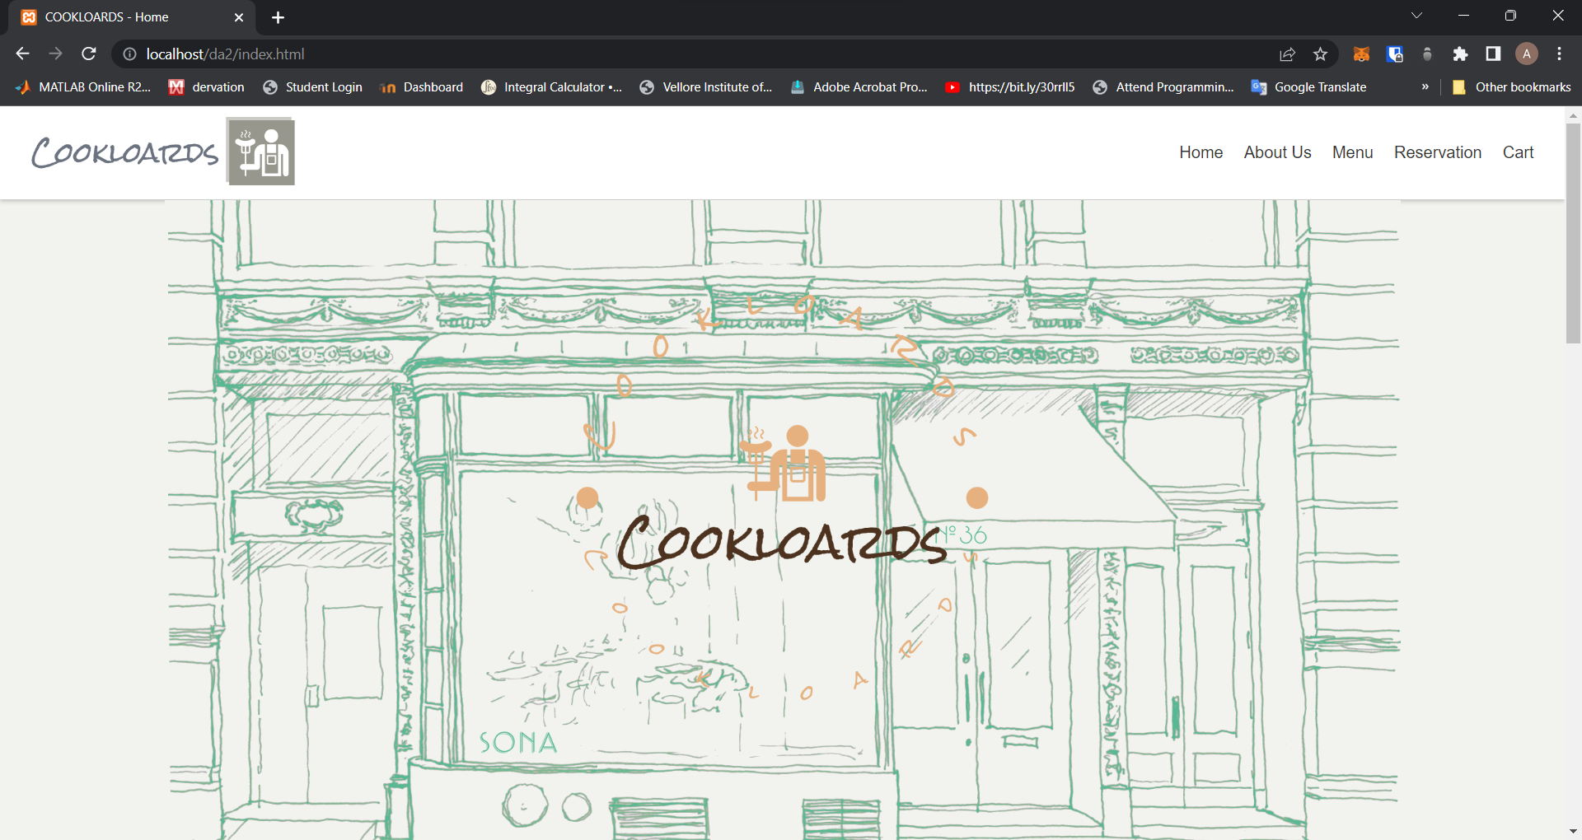

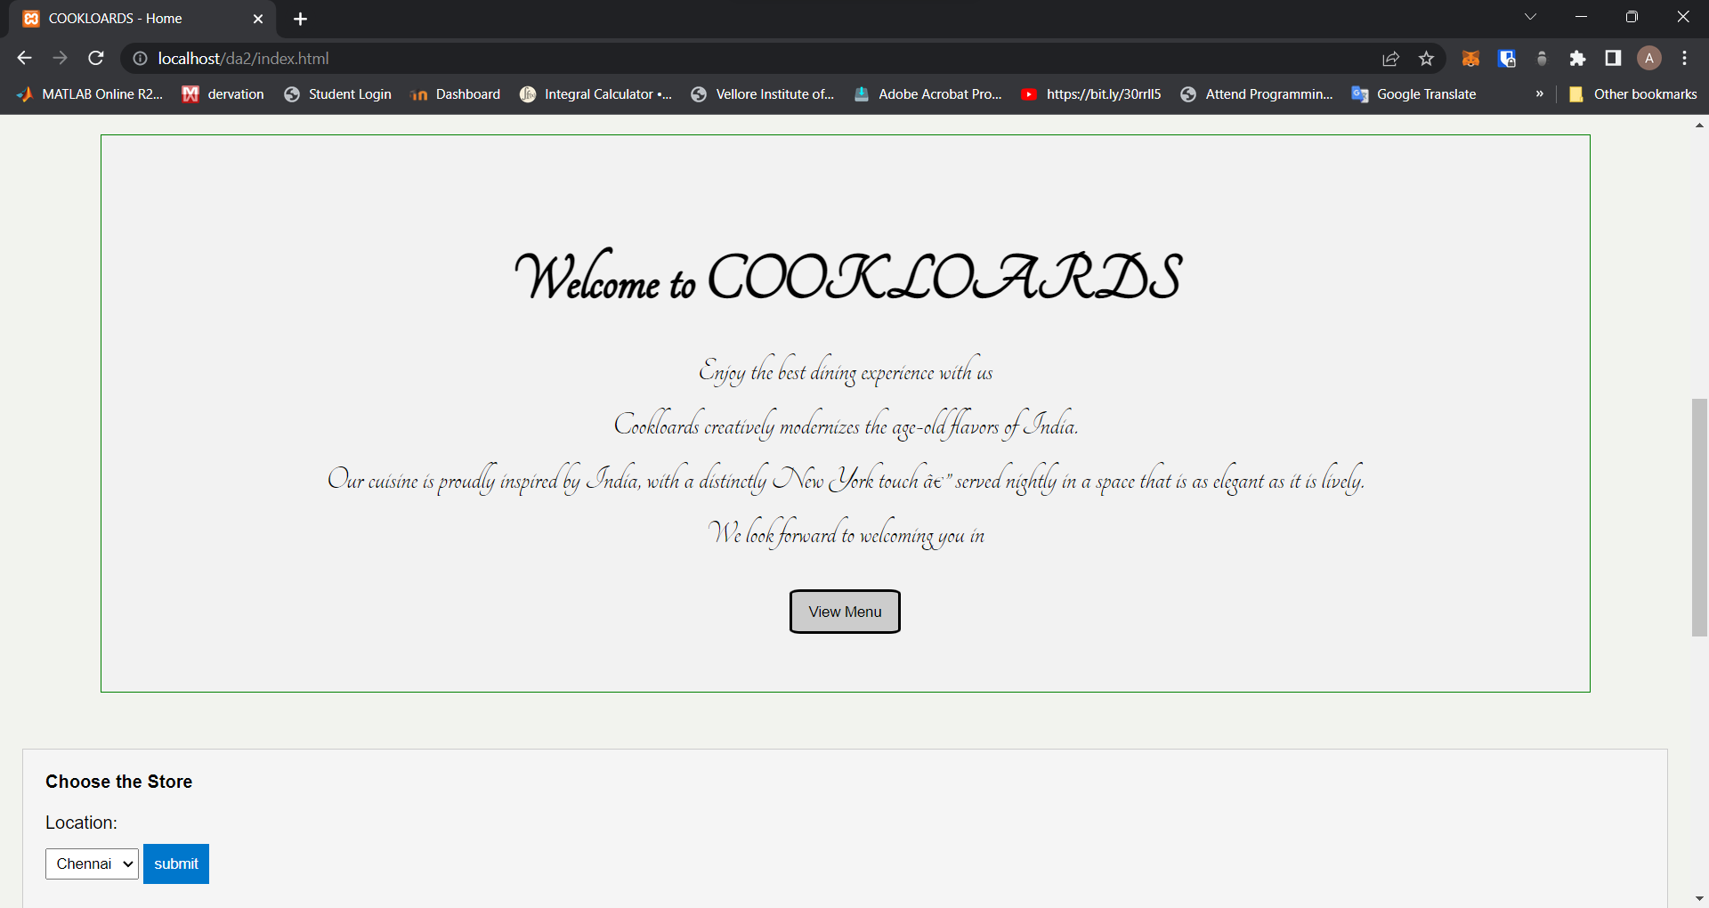

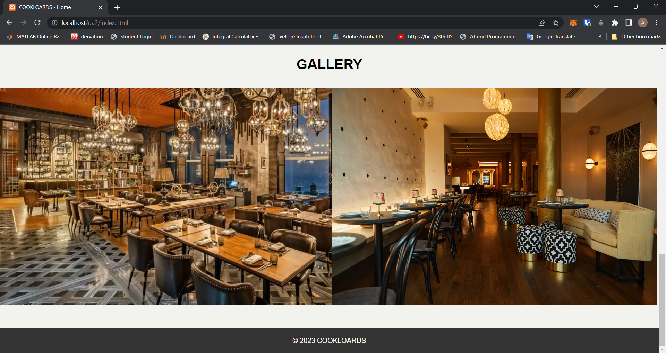

GALLERY CHANGES BASED ON LOCATION:

Chennai:

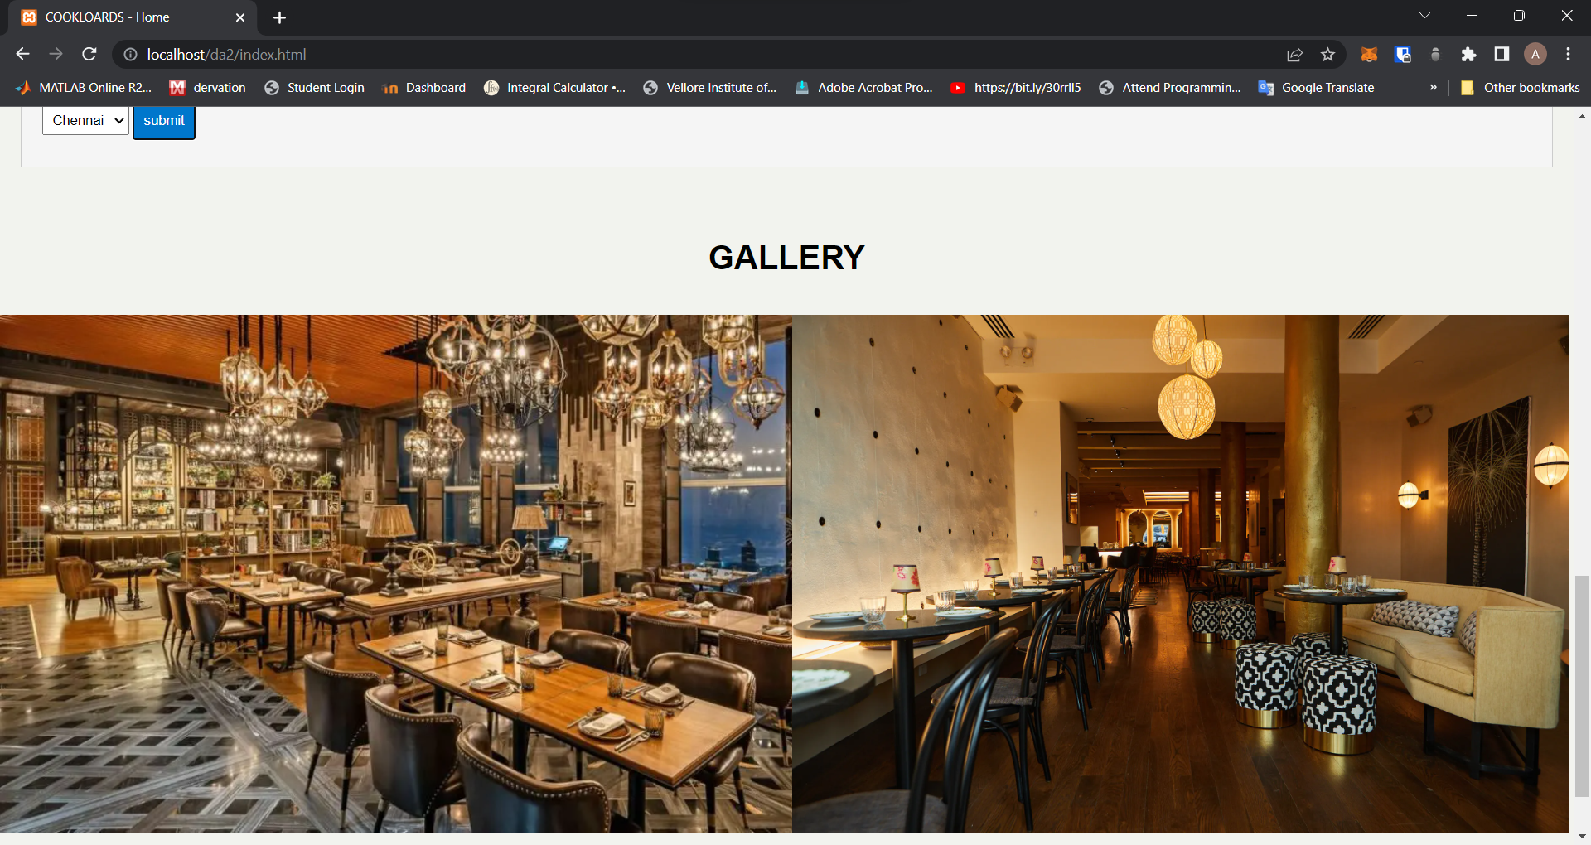

MUMBAI:

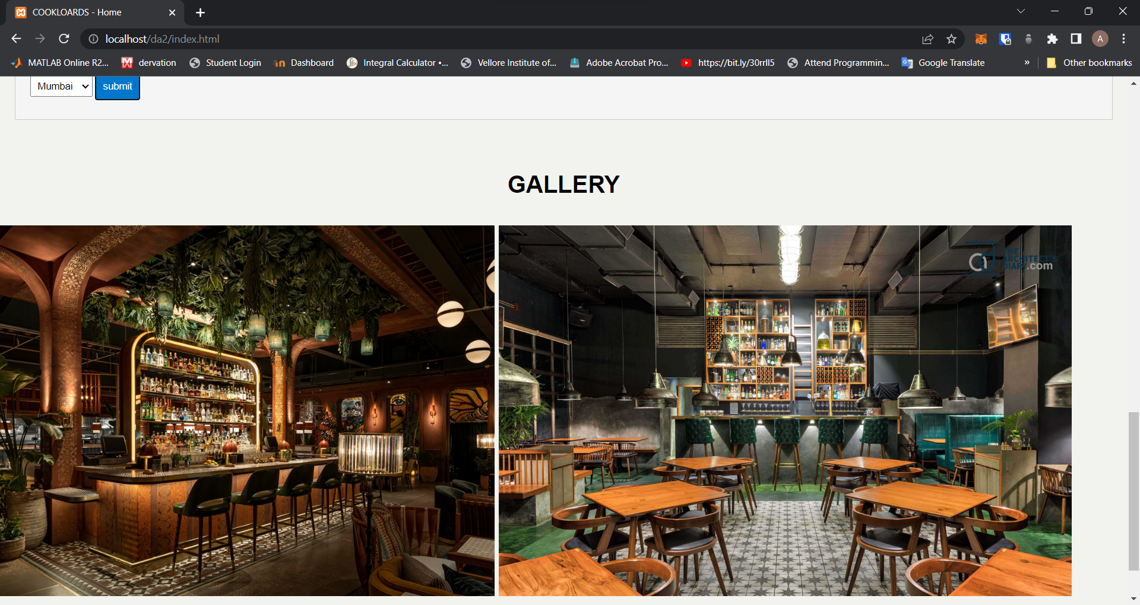



ABOUT US PAGE:

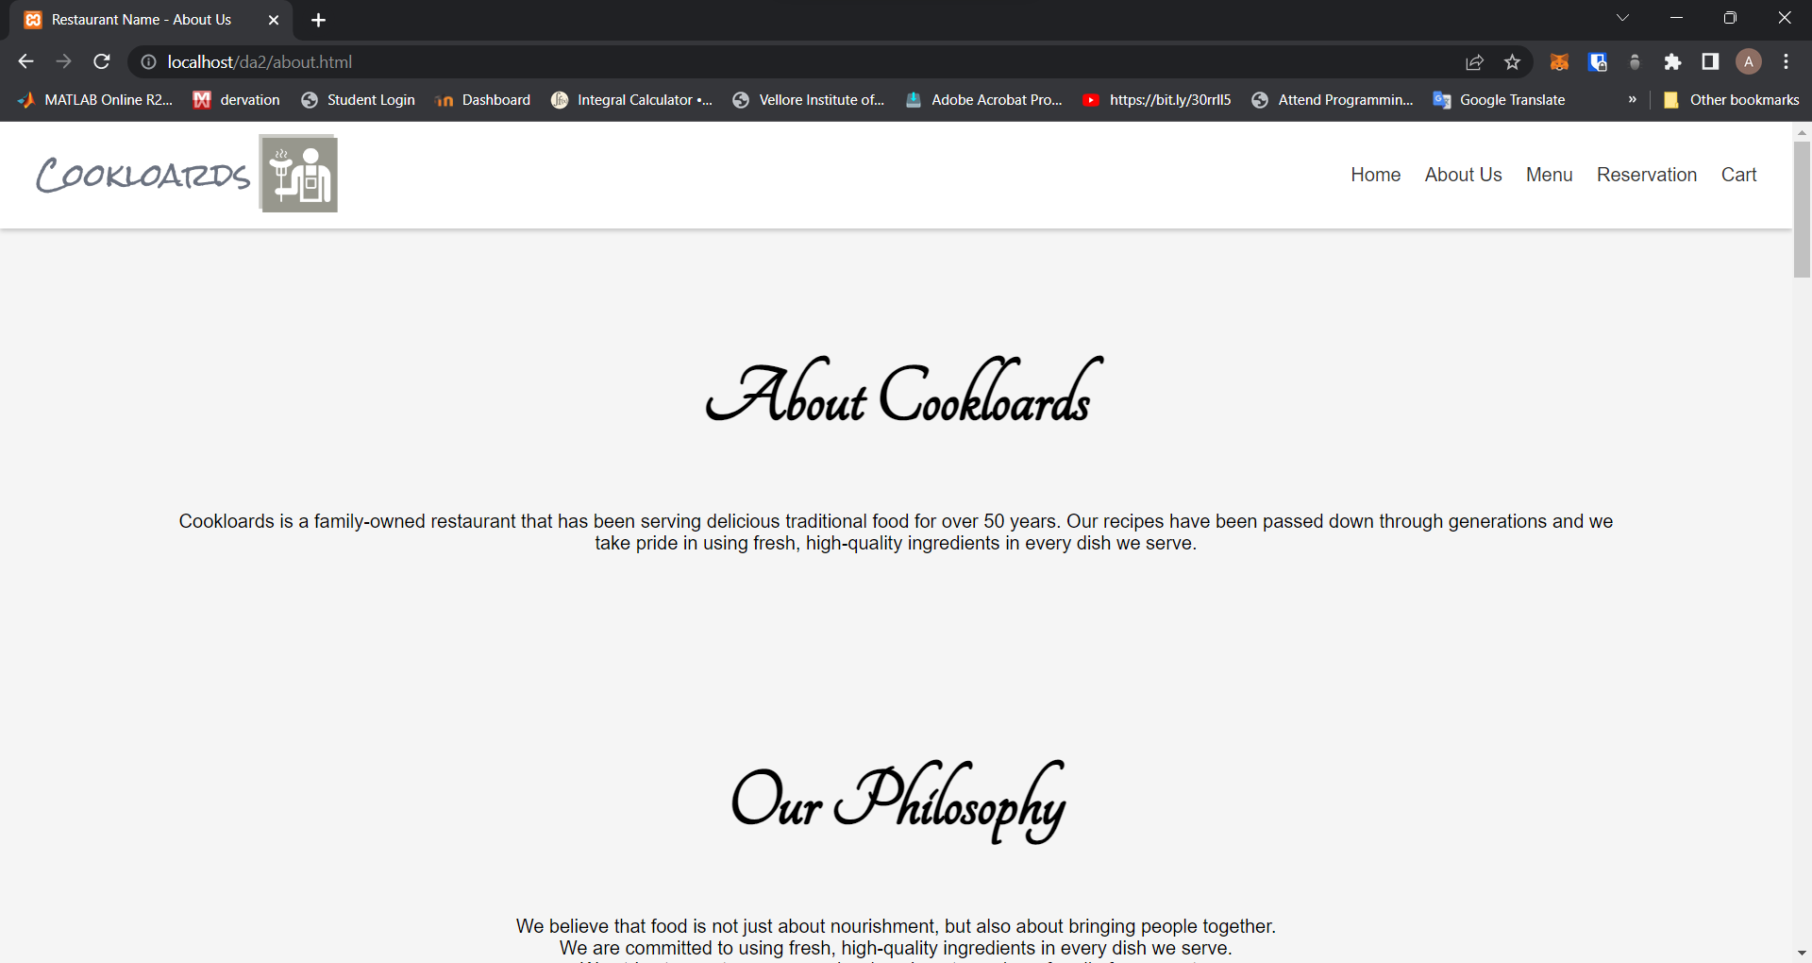

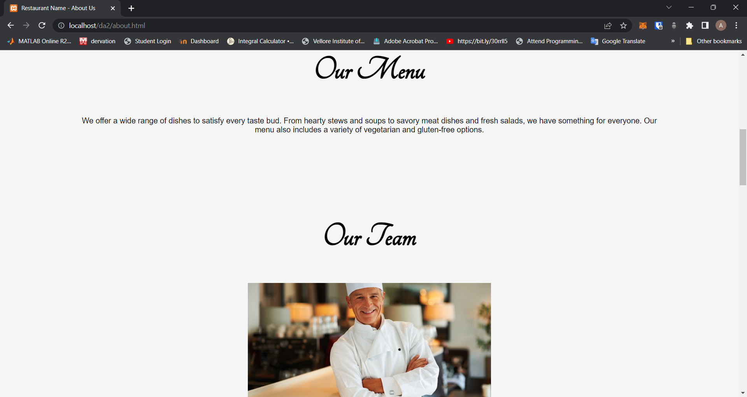

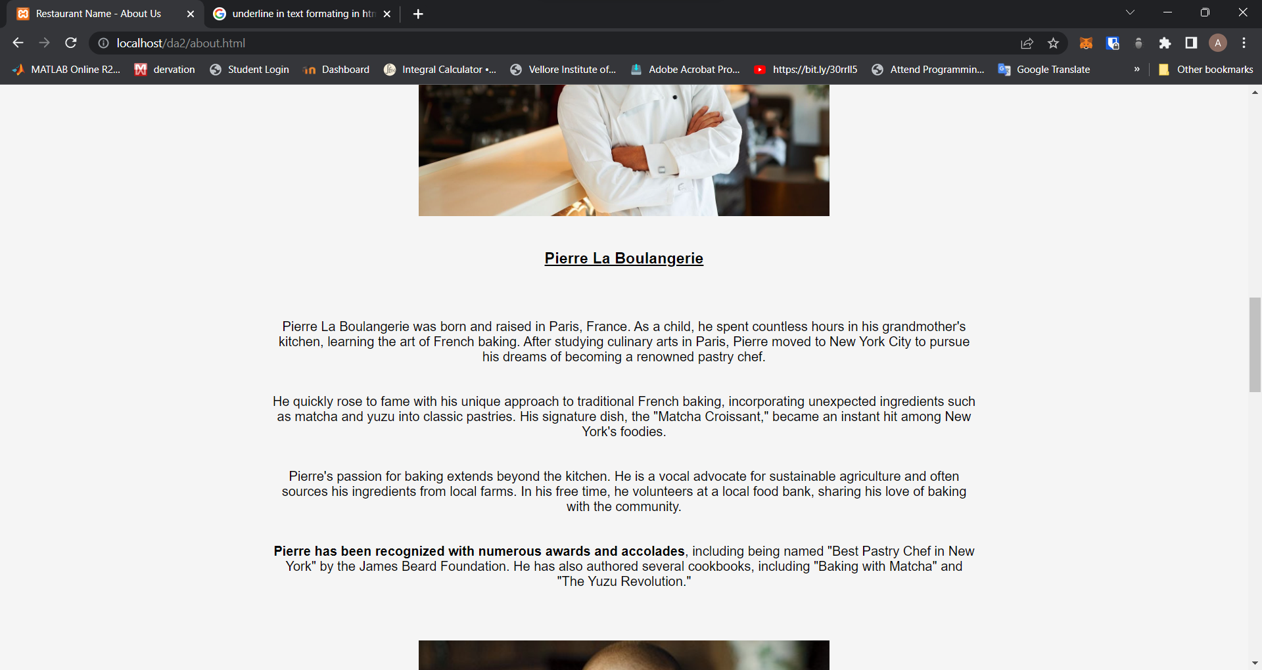

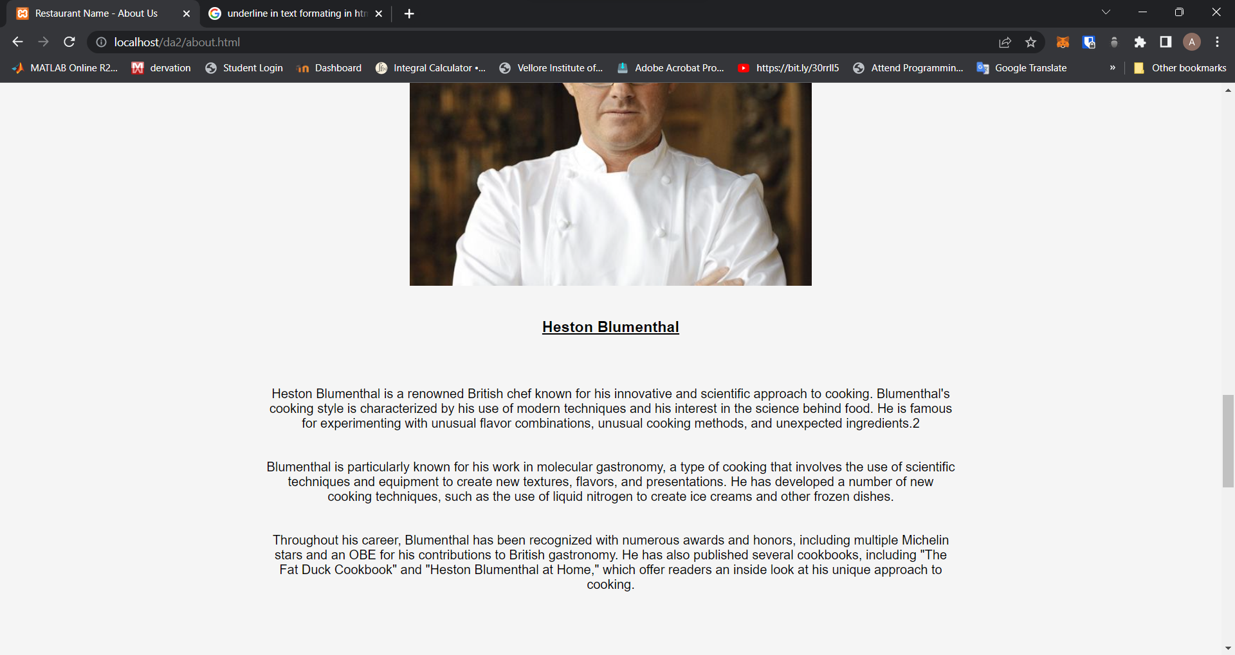

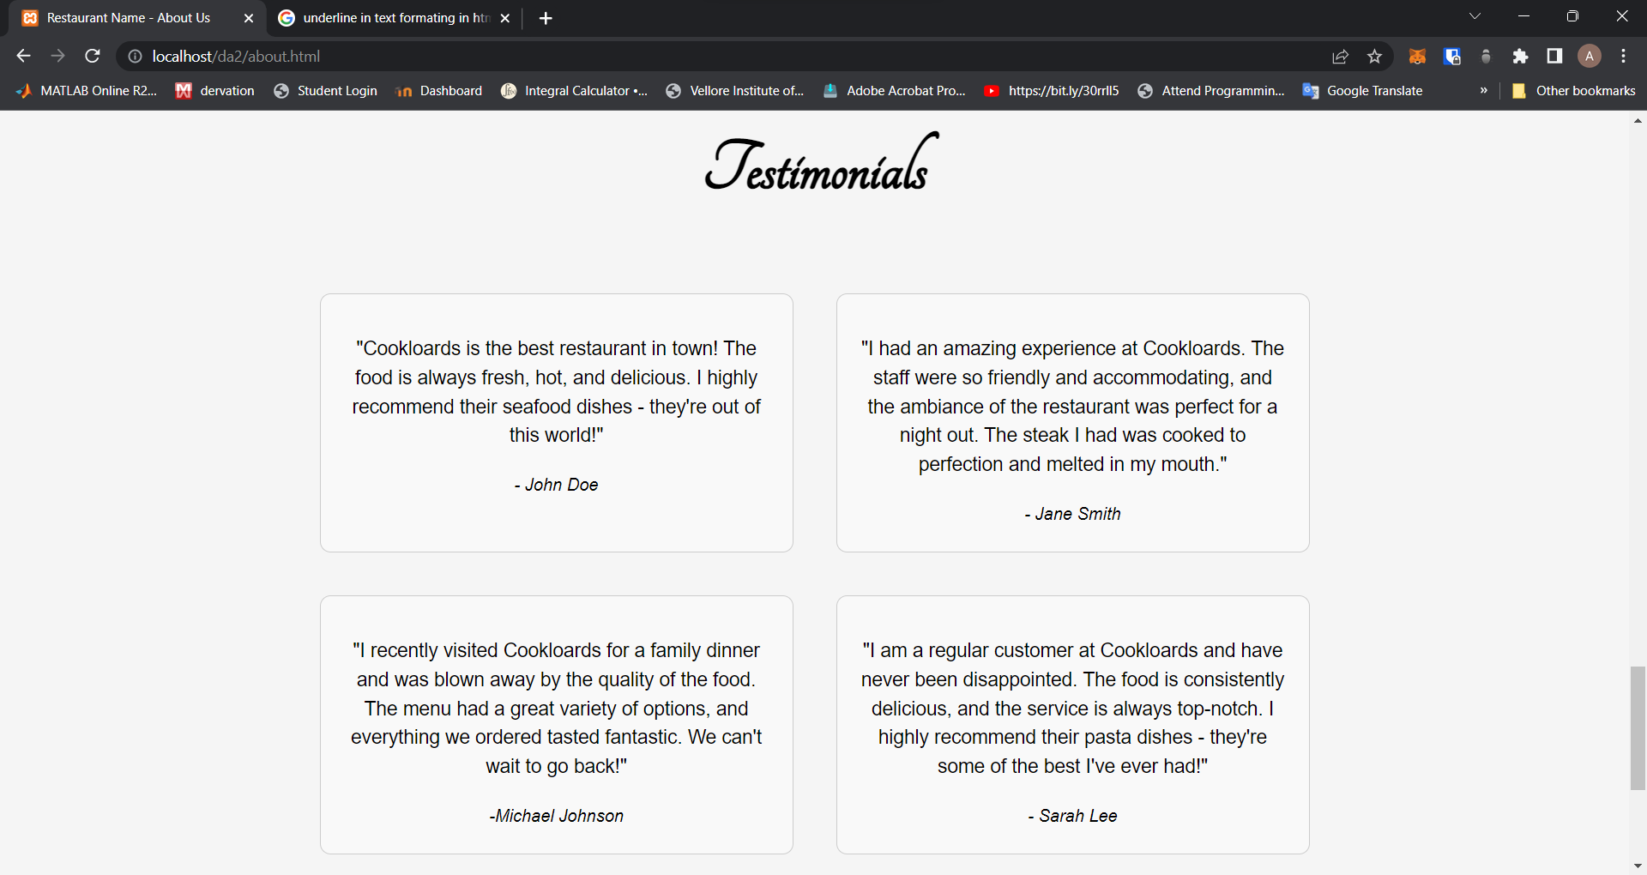

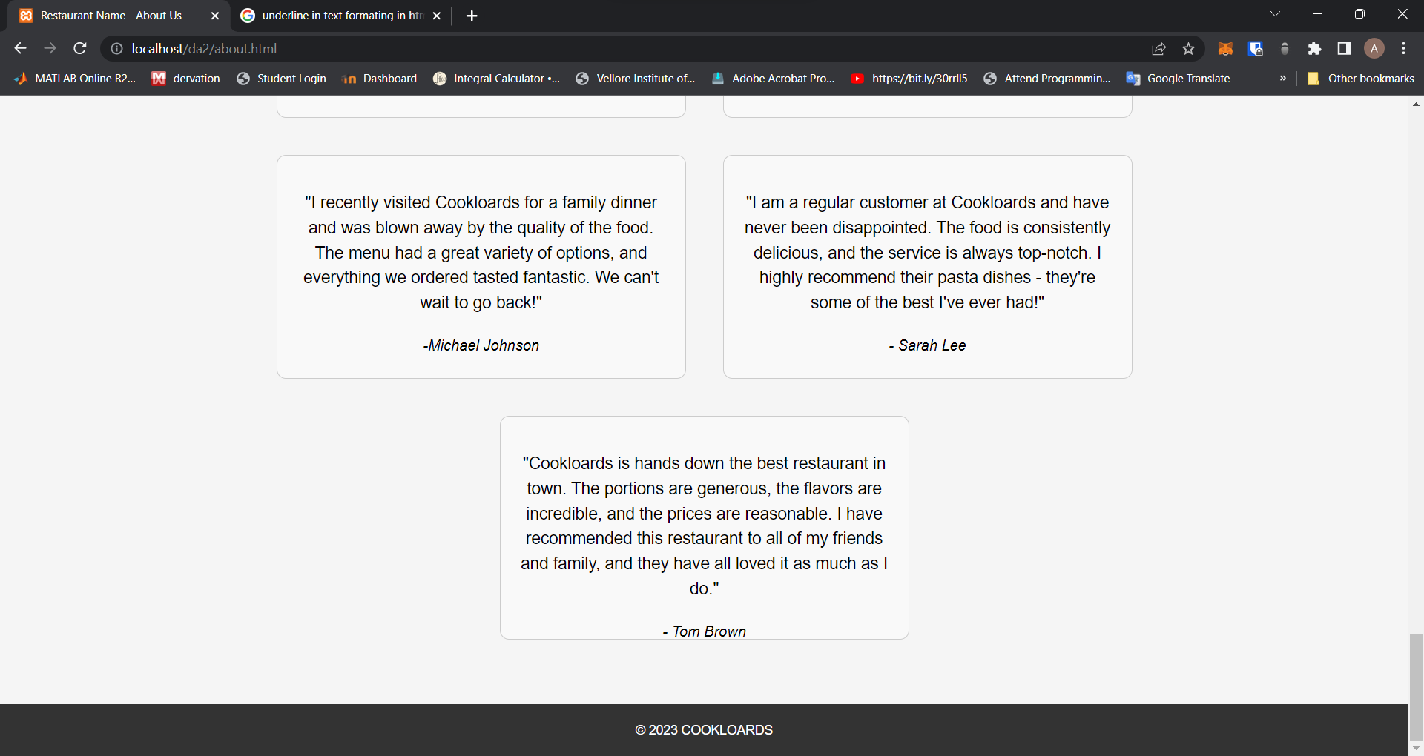

RESTAURENT:

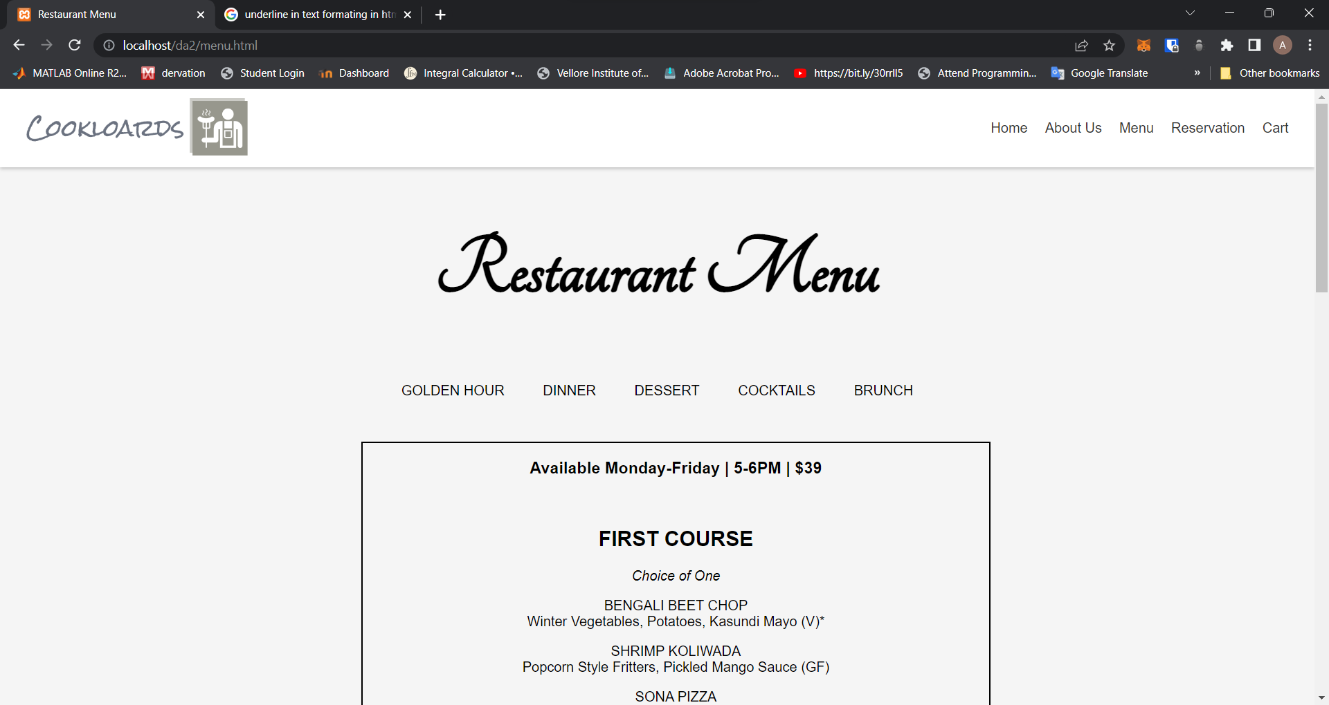

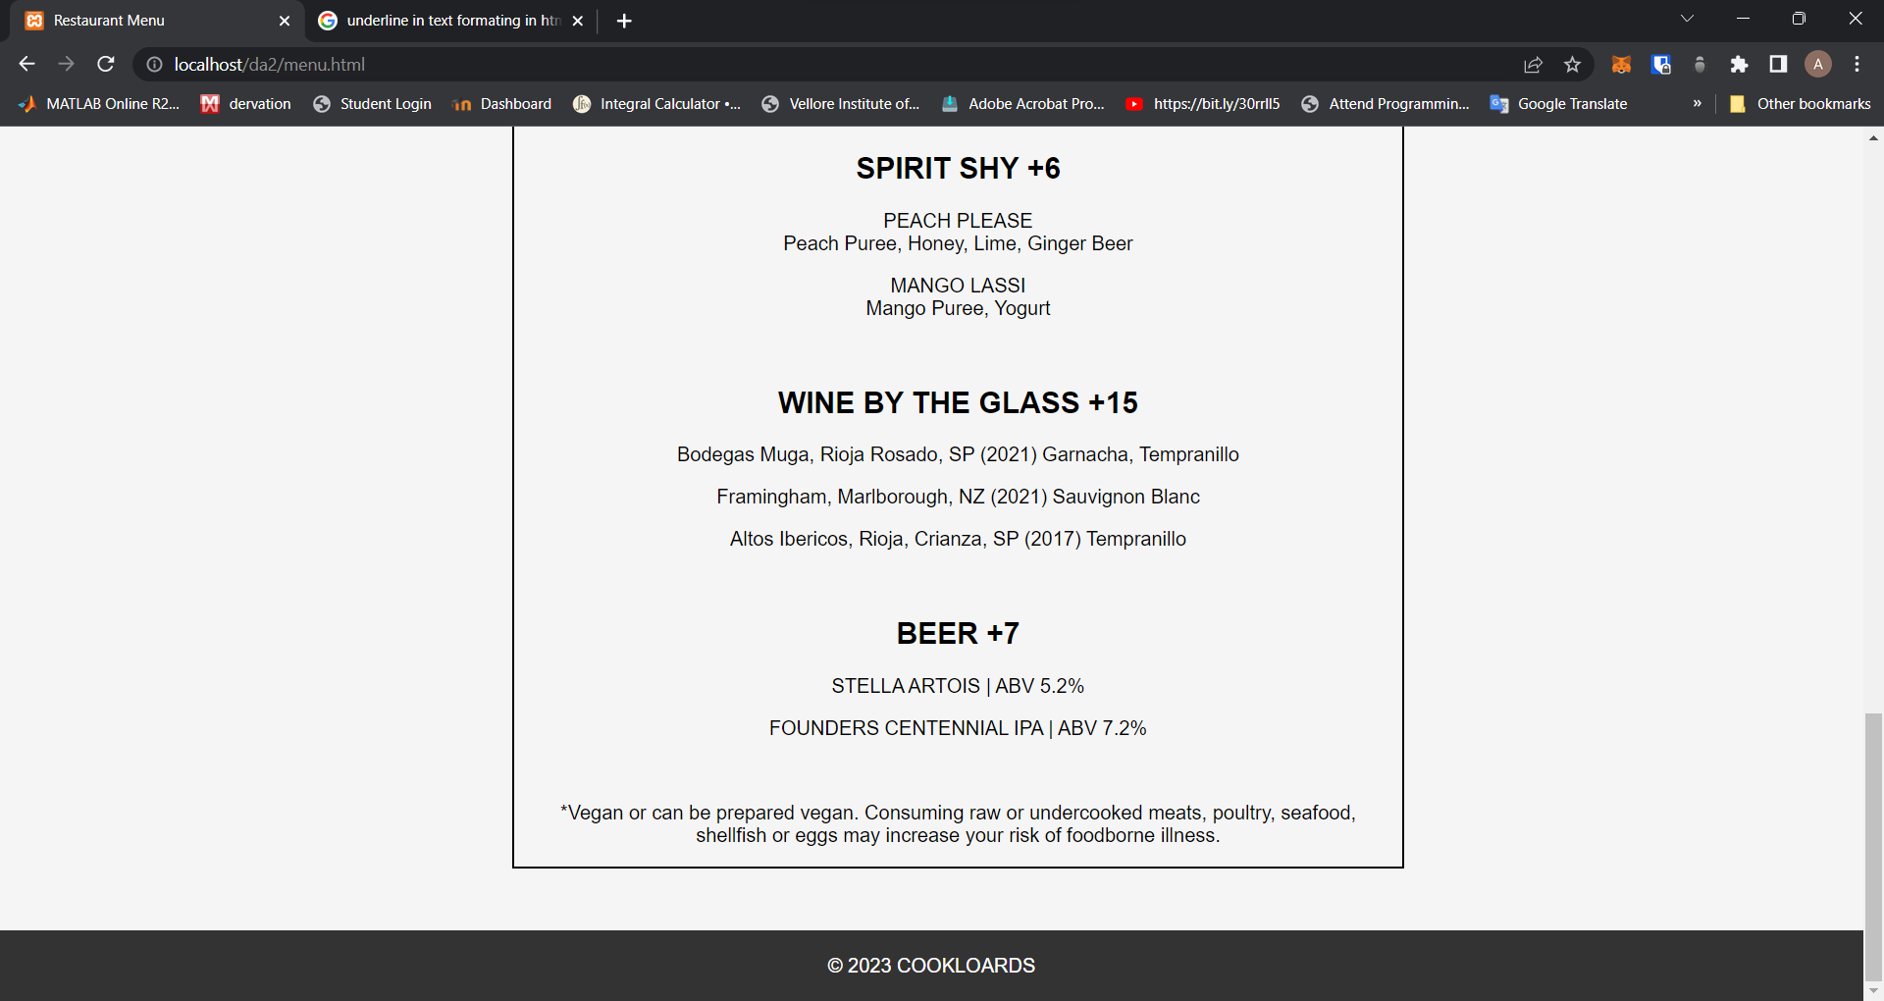

MENU changes with the selction of golden hour dinner desert etc:

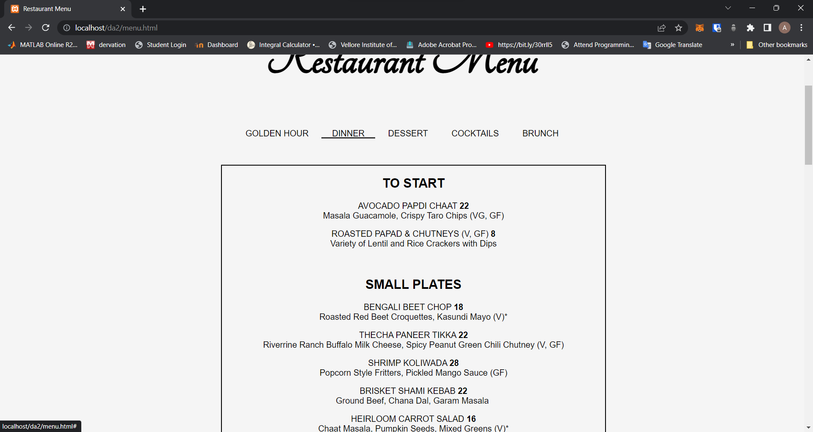

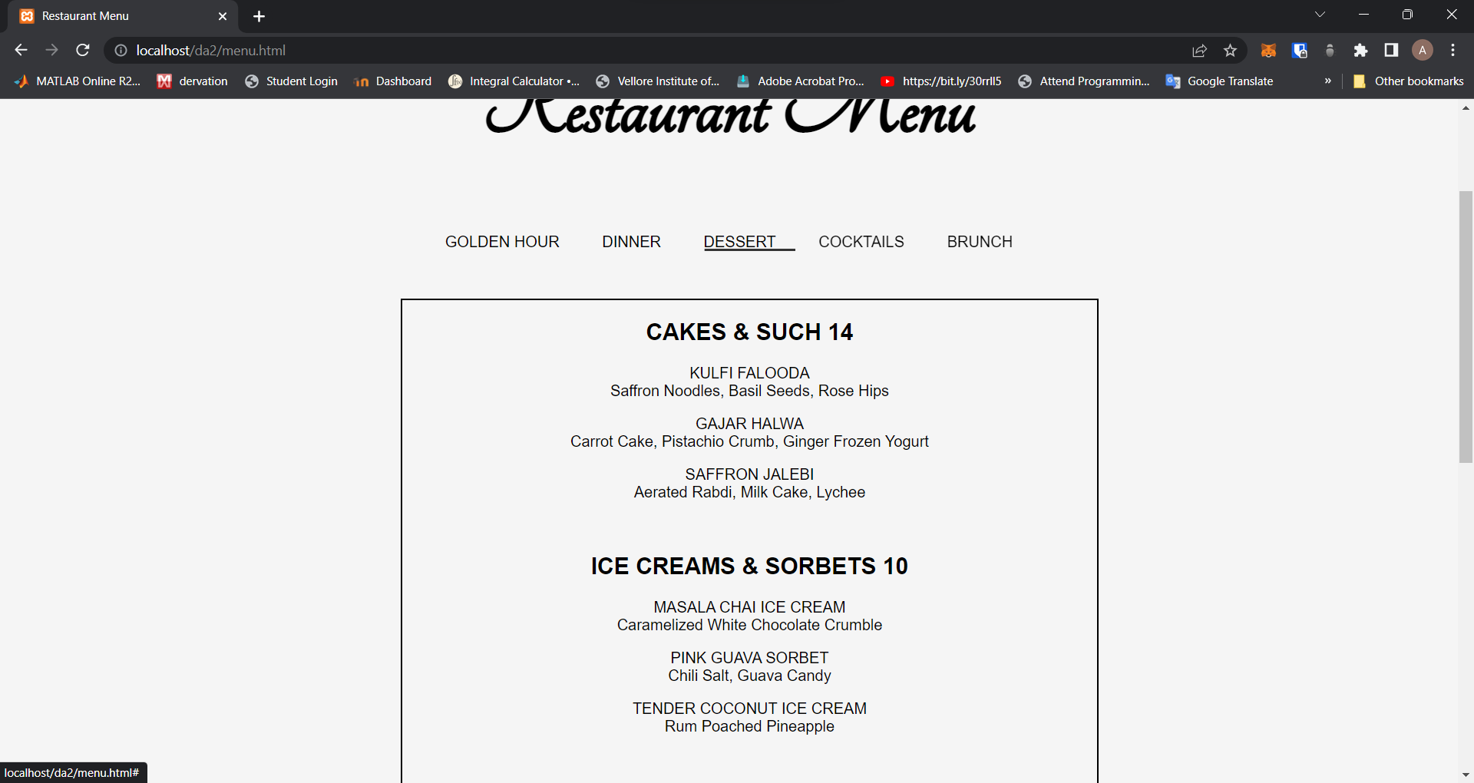

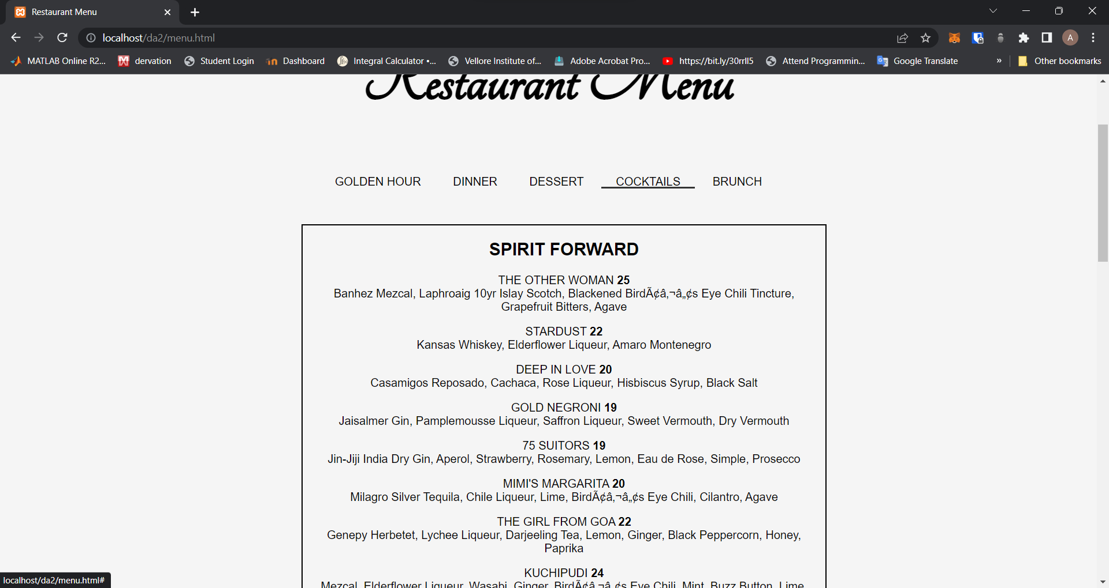

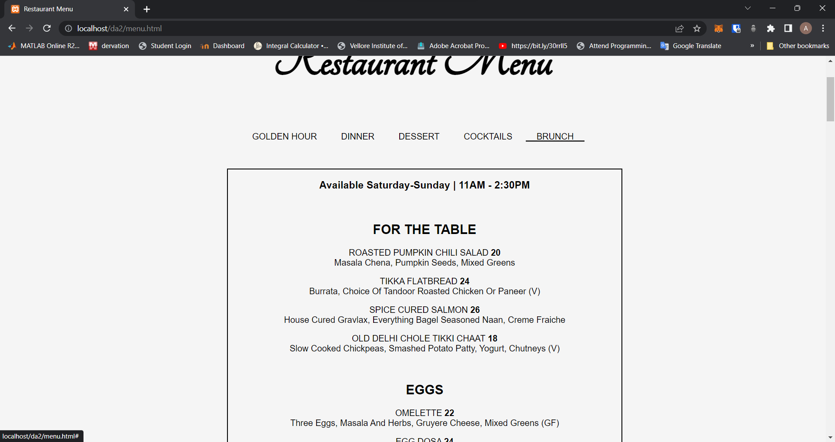

RESERVATION:

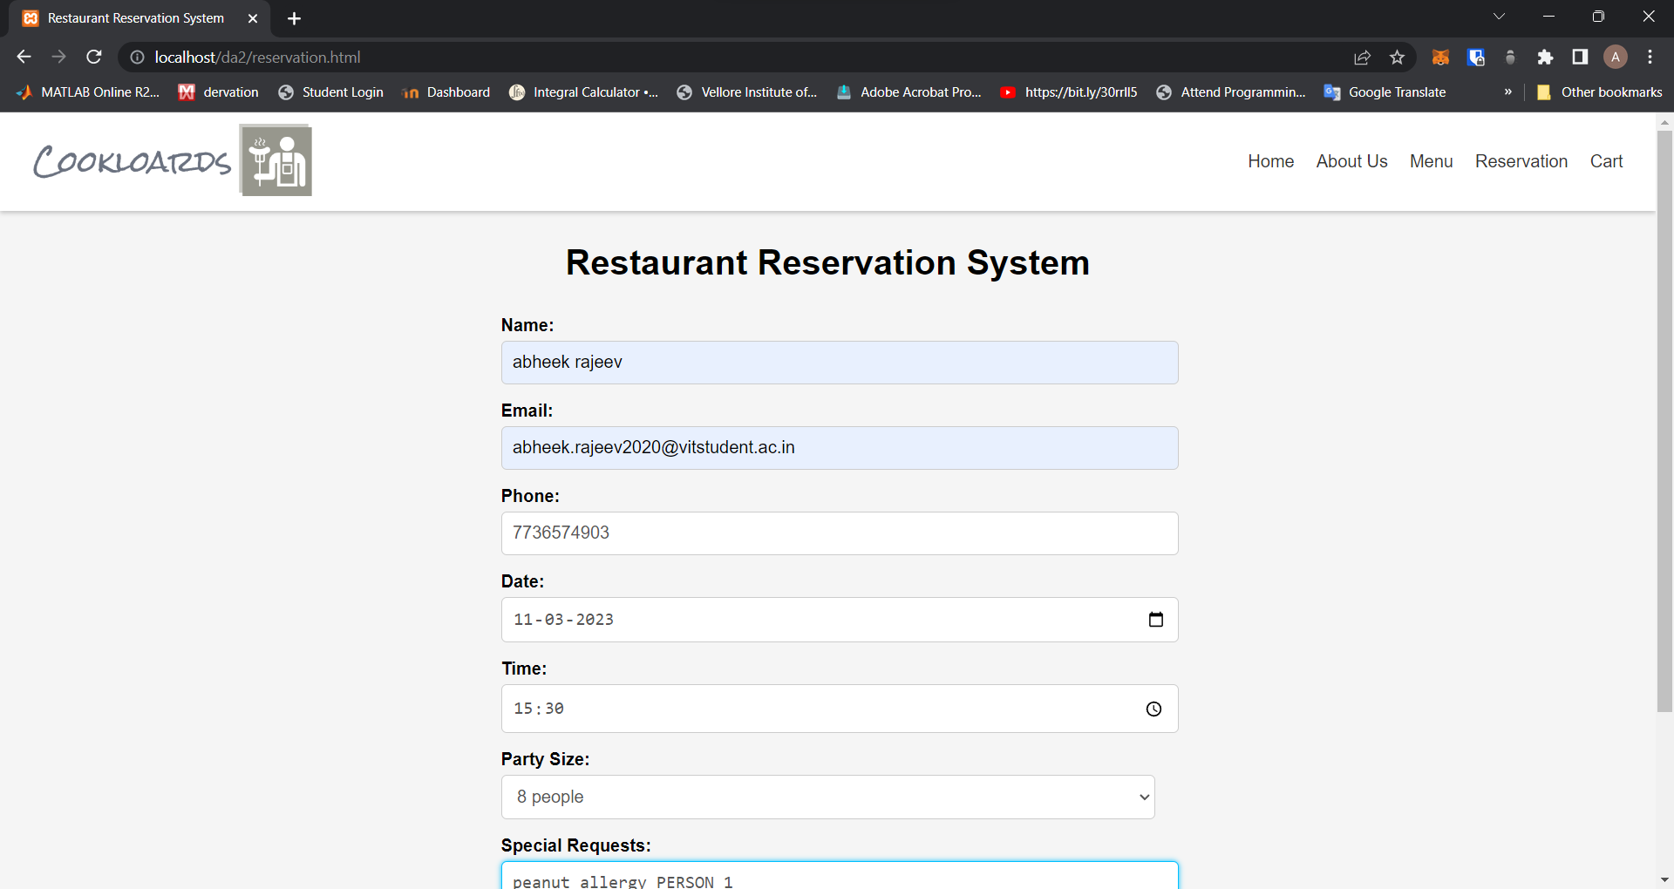

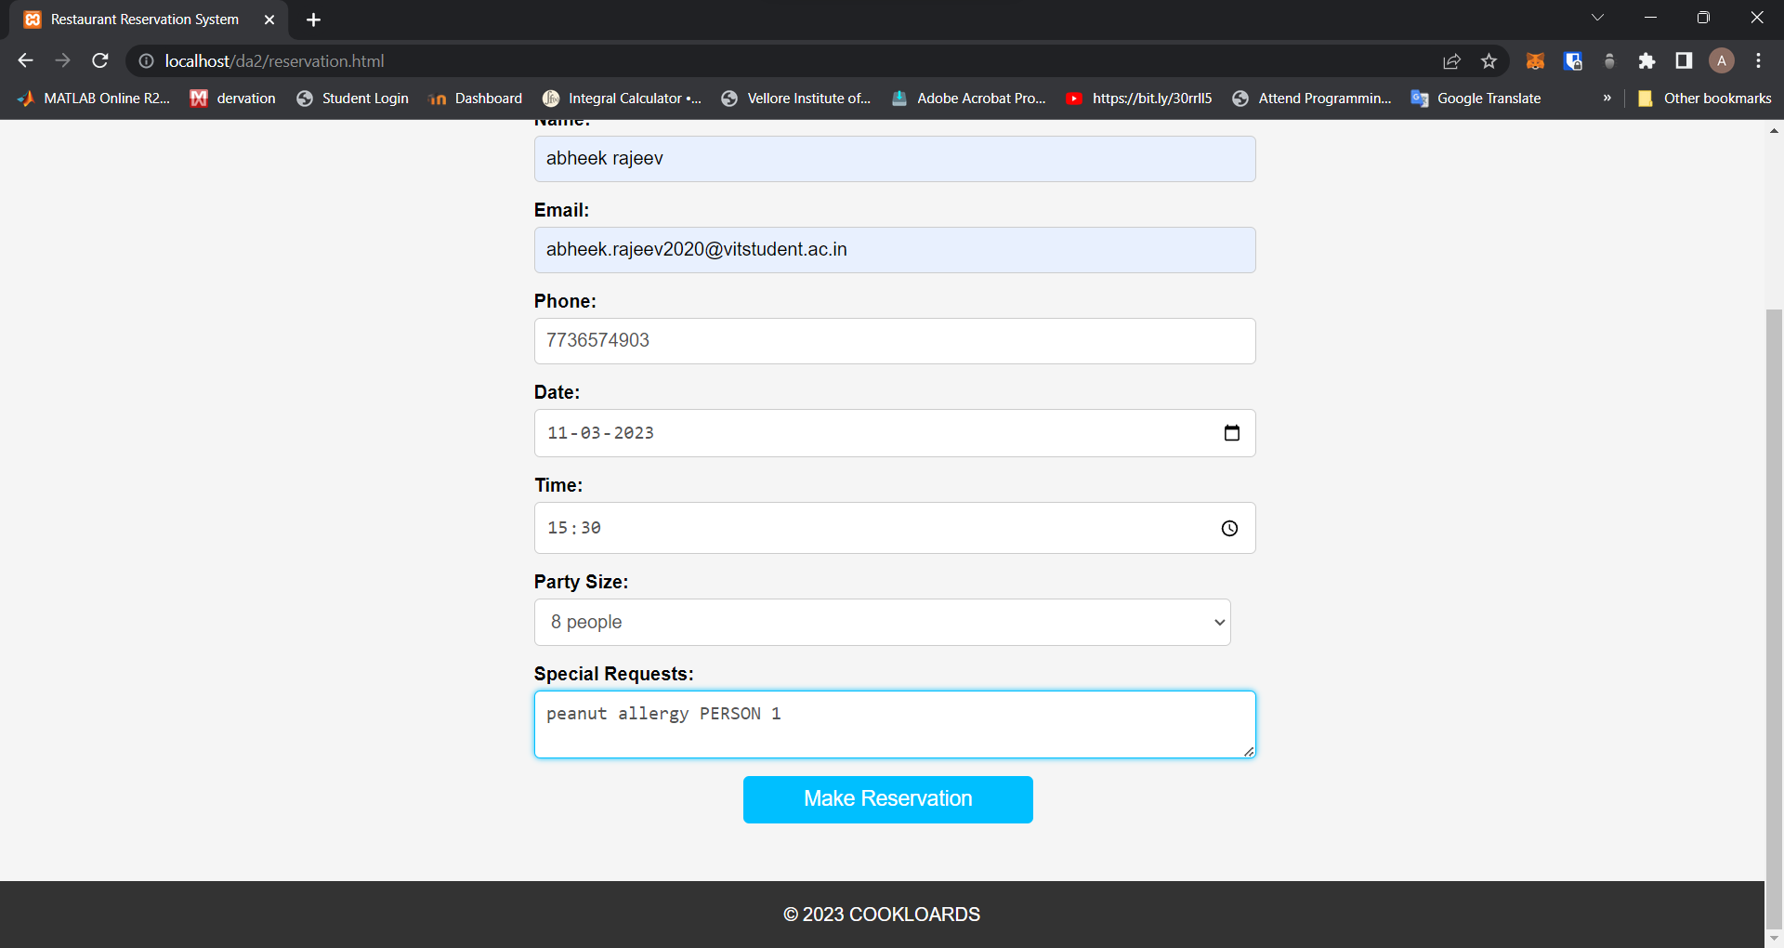

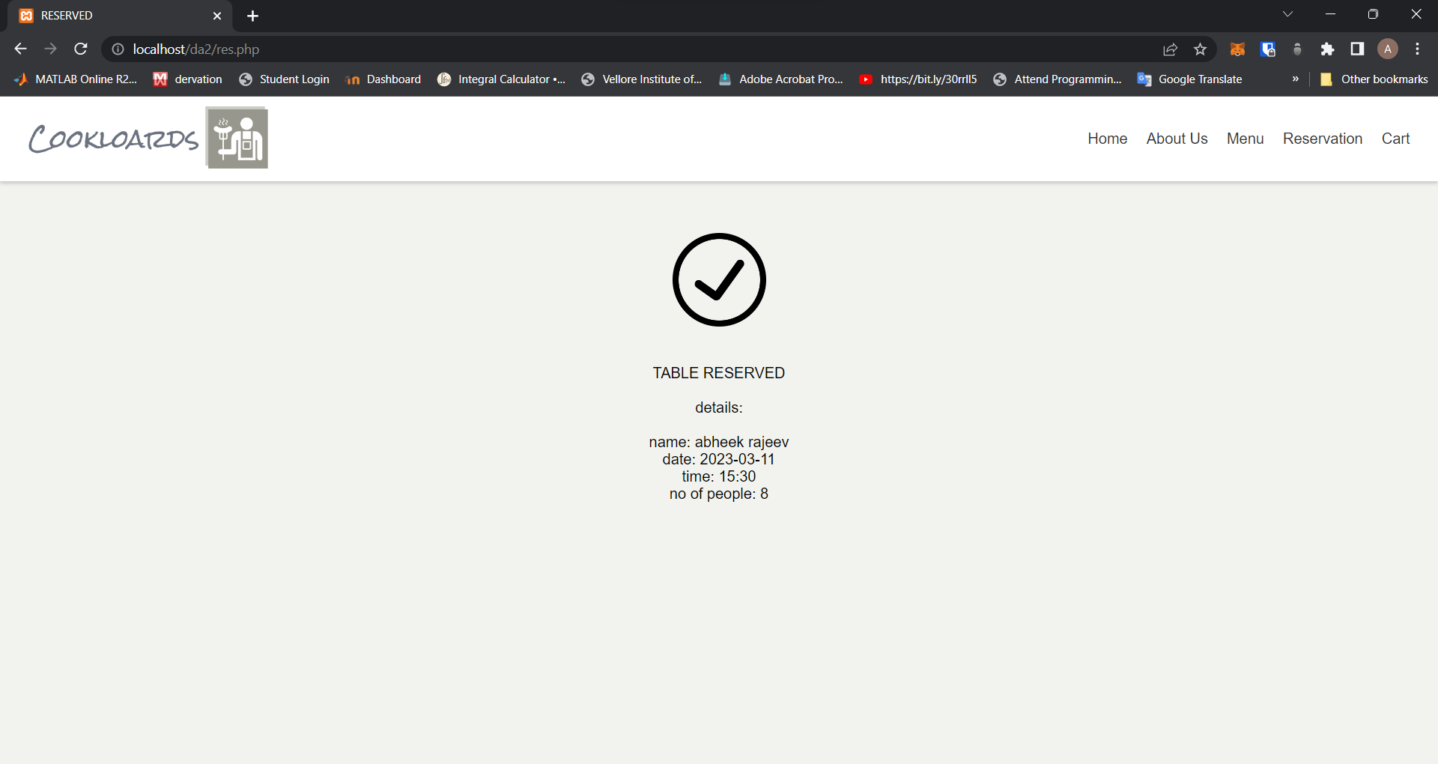

CART:

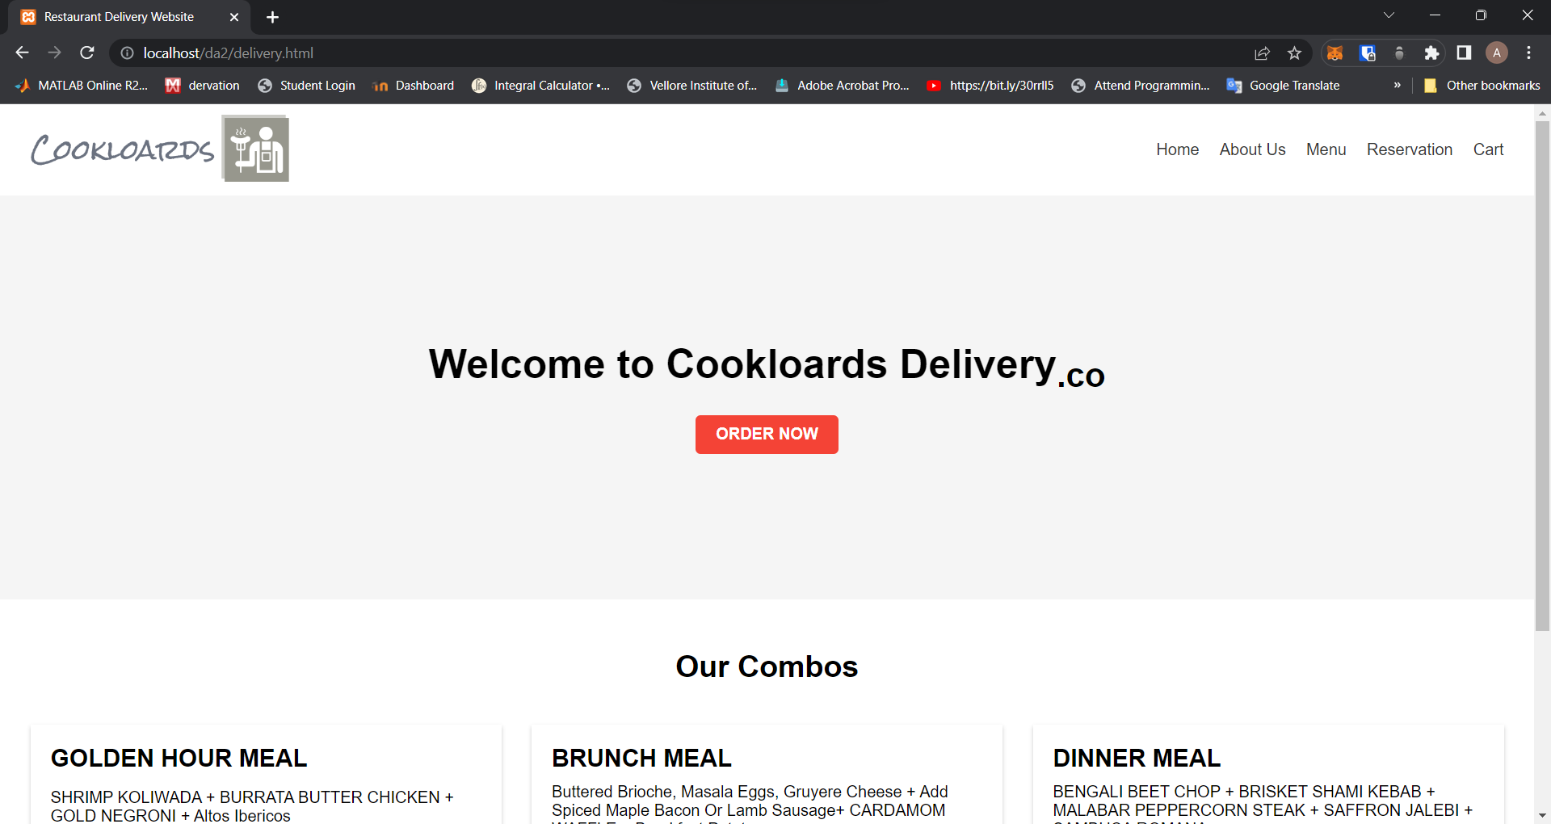

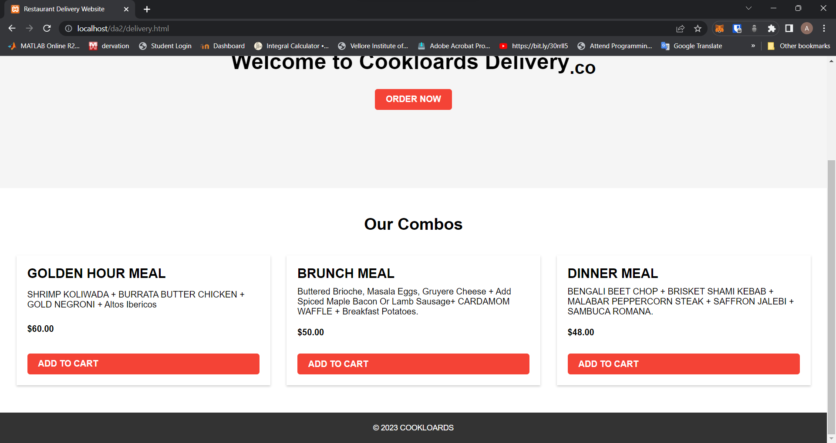

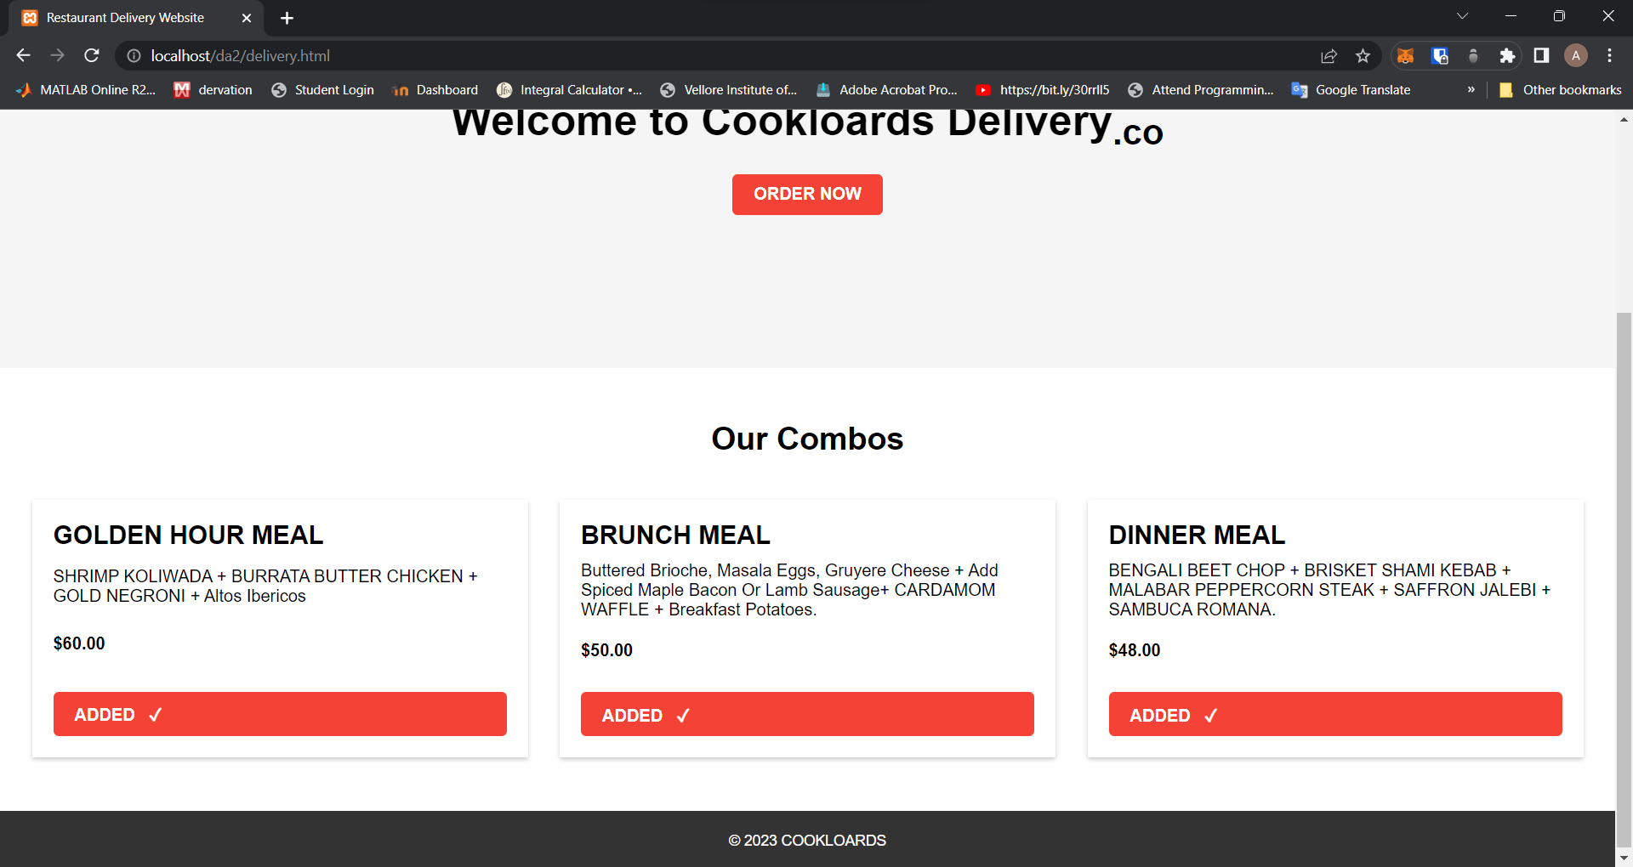

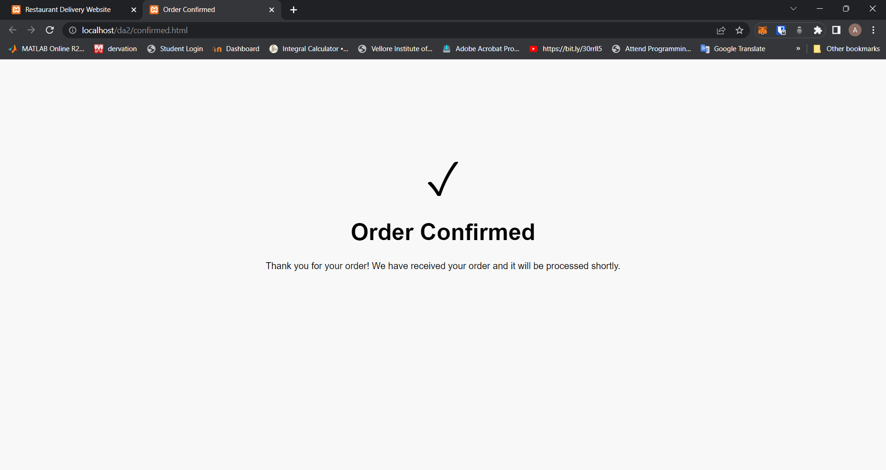

HTML tags:

1. html
2. head
3. body
4. meta
5. title
6. link
7. header
8. main
9. footer
10. h1
11. h2
12. h3
13. h4
14. nav
15. ul
16. li
17. div
18. img
19. a
20. button
21. section
22. br
23. p
24. form
25. fieldset
26. legend
27. label
28. select
29. option
30. input
31. script
32. &nbsp
33. &copy
34. &2714
35. Script
36. U
37. I
38. Em
39. Strong
40. Hr
41. &amp
42. Input text
43. Input email
44. Input tel
45. Input date
46. Input time
47. Label
48. Input textarea
49. Input submit
50. Span
51. Dl
52. Dt
53. Dd

CSS rules:

* Accessing through tag name
* Accessing through class name
* Accessing through id
* Accessing through input tag like select text etc
* Accessing through animation and mouse hover for nav bars

JAVSCRIPT:

* Used to change the menu
* Used to change gallery based on store location
* Used to have a cart system to obtain items selected and show tick on selected ones

PHP:

Used top get the details of reservation and display them on a php site that displays the name and reservation details.